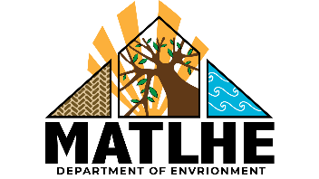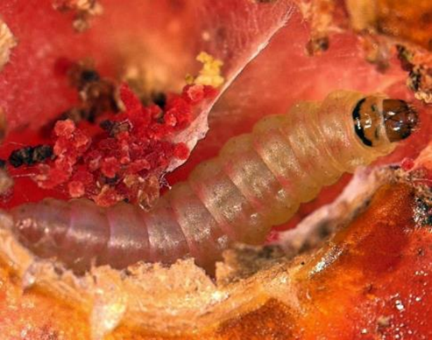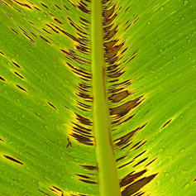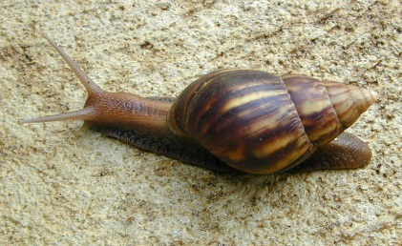

Image: USDA Forest Service - Region 8 Archive, USDA Forest Service, Bugwood.org

Image: Jeffrey W. Lotz/Florida Dept. of Agriculture & Consumer Services/Bugwood.org

**Pest Alert: Have you seen these species?**

**There are a number of invasive species which are detrimental   
to crops and wildlife.**

**1664 491 2075**

[insert website address]

If you suspect you have found these or any similar species please call:

© Chris Malumphy

Giant African land snail

Black sigatoka disease of bananas

Tomato leaf miner

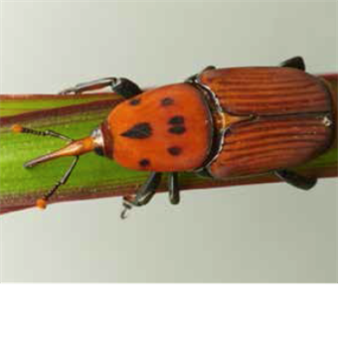

Red palm weevil

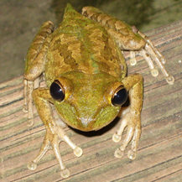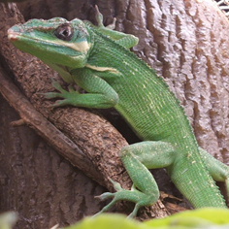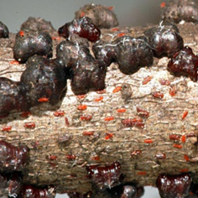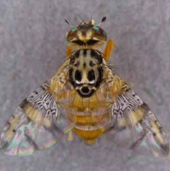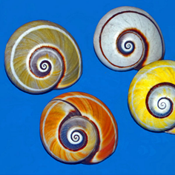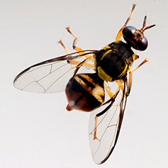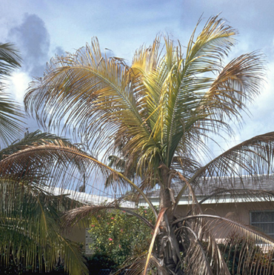

Lethal yellowing of palms

Knight anole

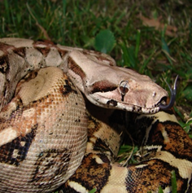

Boa constrictor

Cuban snail

Cuban tree frog

Mediterranean fruit fly

Carambola fruit fly

Lobate lac scale

Image: Hectonichus

Image: Viwat Wornoayporn / IAEA

Image: Fera

Image: Stevenj

Image: Tod Baker

Image: Munkel

Image: Dr Scott Nelson

Image: Fera

Image: Marja van der Straten / NVWA Plant   
Protection Service / Bugwood

Image: Marshman