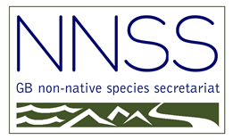

Eighteenth Stakeholder Forum on
Non-Native Species

Wednesday 15th June 2022
Harbour Hotel, 55 Corn Street, Bristol, BS1 1HT

REGISTRATION FORM

Name:

Organisation:

Address:

Email:

Telephone:

How would you prefer to attend the Forum?

Via Teams online

Face to face at the Bristol Harbour Hotel

Do you have any special dietary requirements or need any special facilities at the venue?
…………………………………………………………………………………………….

I would like to display a poster. (Please give a title and details below)
…………………………………………………………………………………………….

……………………………………………………………………………………………………………….

We will be producing a delegate list for all attendees. Because of data protection please let me know if you are unhappy with this and I will remove your details. Your name, affiliation and e-mail address only will be on the delegate list.

Please e-mail to: linda.raine@apha.gov.uk

