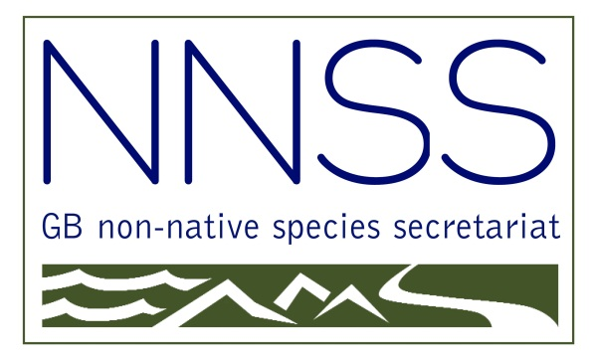

Proceedings of the Sixteenth Stakeholder Forum on

Non-native Species

## The Scotsman Hotel, Edinburgh

## 18 June 2018

|  |  |  |
| --- | --- | --- |
| cid:image001.jpg@01CE7194.E918ACD0 |  | WG_positive_40mm |

**Introduction**

The GB Non-native Species Stakeholder Forum was established in 2004 to provide an opportunity for stakeholders to help shape policy and also to hear about key developments in policy and delivery. It is also used as an opportunity to facilitate networking with colleagues working on non-native species issues across GB. The Forum has been held annually since 2004 and is seen as a key element of the GB approach to non-native species. Since 2008 it has been used to facilitate the active involvement of stakeholders in taking forward the GB Strategy.

The morning sessions consisted of talks to update on developments in the past year. The afternoon workshop sessions provided the opportunity for stakeholders to have a wide-ranging discussions.

Overall, 69 attendees from a broad spectrum of organisations attended the Forum.

*NOTE: The views summarised in the workshop reports represent the views as they were expressed by our Stakeholders.*

**PROGRAMME**

09:30 Registration and coffee

10:00 Welcome address (Richard Pullen, Defra)

10:15 Update on progress since 2018 Forum (Niall Moore, GBNNSS)

**Updates and presentations**

10:30 INNS and Islands in Scotland (Paul Walton, RSPB)

10:55 Managing INNS at the Canal & River Trust (Tom King, Canal & River Trust)

11:15 *Refreshment break*

11:35 Plant Alert: a new tool to report potentially invasive garden plants (Katharina Dehnen-Schmutz, Coventry University)

11.55 Awareness of INNS and uptake of biosecurity measures by GB recreational anglers (Emily Smith, Angling Trust)

12:15 Introduction to workshop sessions

12:30 *Lunch*

13:30 **Workshop session:**

* + **Workshop 1:** Gathering views on management objectives for widely spread species
  + **Workshop 2:** Brainstorming key actions for priority pathways
  + **Workshop 3:** Research strategic plan (discussion of draft plan)

15:00 *Refreshment break*

15:20 Open session

15:50 Closing remarks/next steps

16:00 Close

**Workshop Reports**

**Workshop 1: Management of widely spread species**

**Chair:**  Stan Whitaker (SNH) and Jenny Park (SNH)

**Background**

Although the main emphasis of the EU Regulation is on prevention and rapid eradication, it recognises the need to manage the impact of invasive alien species of Union concern that are already established. Article 19 requires Member States to put in place ‘management measures’ for widely spread species that are cost-effective and proportionate to their impact on biodiversity. 'Management measures' are defined as any lethal or non-lethal physical, chemical or biological actions aimed at the eradication, control or containment of a population; a 'widely spread' species is one which has gone beyond the naturalisation stage and whose population is self-sustaining.

The updated GB Strategy (2015) set a series of ambitious aims and objectives in relation to long-term control of species. Key Action 5.1 calls for us to “develop a decision support system to help prioritise strategic responses for well-established species at a GB, national and/or regional level” and 5.2 to “develop and facilitate key GB level long-term management programmes that are cost-effective, evidence-based and proportionate to the threat level.” Government resources are limited, are unlikely to increase substantially and are likely to be increasingly directed at prevention and rapid response. However, issues related to species that require long-term control continue to grow.

To control INNS most effectively requires strategic, coordinated and sustained action. For long-term INNS control the key is working in partnership, where multiple stakeholders pool expertise, local knowledge, resources and funding over a continuous period of time to deliver against jointly agreed objectives. The objectives for managing INNS in different parts of the country will depend on the stage its invasion is at. When resources are limited it is important that priorities are agreed and understood by all the stakeholders.

The workshop aimed to explore ways to prioritise strategic responses for well-established species at a GB, national and regional level, using widely spread species of Union concern as examples.

How to prioritise management of widespread invasive species?

Consider whether the species is:

* Commercially valuable e.g. carp
* At an early stage of naturalisation, e.g. carp

Consider prioritising the following:

* Biological assets
* Manageable pathways
* Management programmes which are financially feasible
* Areas where regional coordination is possible
* Options which have political will
* Sustainable control actions

Other recommendations:

* Consider the scale of priorities – national and regional
* Define assets for protection, e.g. floating pennywort and navigational waterways
* Consider the degree of impacts, e.g. climate change links
* Make use of local professional expertise, e.g. weed control companies, ecologists etc to level funding from their clients
* Make use of existing networks, e.g. volunteers
* Take account of biocontrol options
* Give up on some species, e.g. Japanese knotweed
* Develop BAP type INNS plans
* Carry out cost benefit analysis

**Workshop 2: Brainstorming key actions for priority pathways**

**Chair:** Olaf Booy (GB NNSS) and Jo Long (SEPA)

**Background**

Prioritising invasive non-native species pathways is a requirement of both the EU IAS regulation and the GB Invasive Non-native Species Strategy:

* Article 13 of the EU IAS regulation requires Member States to carry out a comprehensive analysis of the pathways of unintentional introduction and spread of invasive alien species of Union concern (at least) in their territory; while,
* Key Action 3.1 of the GB Invasive Non-native Species Strategy states that we will develop a robust approach to prioritising pathways based on potential impact of the species introduced and the effectiveness of pathway management.

The UK has recently completed a comprehensive analysis of pathways to identify those that pose the most risk of introducing harmful invasive non-native species (<https://secure.fera.defra.gov.uk/nonnativespecies/downloadDocument.cfm?id=1980>).

This identified six priority pathways for initial consideration:

1. Hull fouling
2. Horticulture escapes
3. Contaminants of ornamental plants
4. Ballast water
5. Stowaways on fishing equipment
6. Zoo and botanic garden escapes

The EU IAS regulation requires that Pathway Action Plans are developed for all of these pathways. While good progress has been made on some fronts (for example the [zoo escapes PAP](http://www.nonnativespecies.org/index.cfm?sectionid=135)) there are a number of pathways that have not yet been fully addressed (see Table 1 for an NNSS take on progress towards the development of PAPs).

**The aim of this workshop was to gather ideas for how to reduce the risk from these pathways**.

Questions to consider included:

1. Are there any comments / views on the pathways identified as initial priorities? Are there any specific aspects of these pathways (e.g. specific routes, types of vehicle / import, points of entry) that should be considered particularly high risk or for which there is a particularly good opportunity to reduce risk?
2. How should we take forward PAPs for these pathways where they are not already in progress (refer to Table 1)? What stakeholders / delivery mechanisms should be involved?
3. What key actions can we take to manage these pathways?

(Olaf providing the notes from this breakout session)

**Workshop 3: Research strategic plan (discussion of draft plan)**

**Chairs:** Niall Moore (GB NNSS) and Sarah Webster (Defra)

Niall / Sarah to provide the notes

###### Feedback from attendees

69 delegates attended the Forum and 21 feedback forms were returned.

All 21 agreed that holding an annual Forum was very worthwhile activity.

**Comments about the Forum which worked well:**

‘Good range of topics’.

‘‘Workshop very interesting’.

‘The supporting paperwork was good and location and presentations were excellent’.

‘A good representation of key stakeholders’.

‘This was my first Forum and I found it very informative.’

‘Attending the workshop and being able to go into detail about some of the topics was really helpful’.

Excellent Forum, as always, the informal discussions as useful as the formal sessions’.

‘Great opportunities to network’.

‘Mixture of talks from different organisations was good.’

‘Excellent presentations and contributions in the workshop which expanded my knowledge’.

**Comments about the Forum which didn’t work well:**

‘Sometimes the workshop lost track of the objective of the session’.

‘Workshops are a good idea but they need better facilitation and focus’.

‘Enjoyed the talks, not so much the workshop’.

‘I liked the workshop discussing real issues but they could have benefited from being facilitated by someone other than directly involved staff’.

‘Keep the speakers to time’.

‘Give speakers 5 minutes notice to finish on time’.

‘Forum should be chaired more tightly – all sessions overran significantly. Each talk should have been absolutely max 20 minutes, the relaxed approach doesn’t work and is frustrating for delegates, speakers and venue staff’.

**Other comments:**

‘Send summary from different workshops to all via e-mail after the meeting’.

‘Arrange a meeting the night before for networking’.

‘2 days would be more useful considering travel’.

‘I’d like to be able to participate in more than one workshop session’.

‘Circulate who is attending in advance’.

**Most suggested locations for the 2018 Forum were:**

York

Wales

**Secretariat Website**

The table below shows the frequency of delegate visits to the website reported on the feedback forms.

|  |  |  |  |  |  |  |  |  |  |
| --- | --- | --- | --- | --- | --- | --- | --- | --- | --- |
|  | **2019** | **2018** | **2017** | **2016** | **2015** | **2014** | **2013** | **2012** | **2011** |
| Never |  |  |  |  |  |  |  |  |  |
| Rarely | **4** | 2 | 4 | 2 | 4 |  | 2 |  | 3 |
| Once per month | **10** | 7 | 14 | 10 | 10 | 5 | 6 | 2 | 11 |
| Once per week | **1** | 2 | 6 | 5 | 6 |  | 4 | 8 | 8 |
| Several times per week | **1** | 3 | 5 | 3 | 7 | 2 | 2 | 8 | 2 |

**The most useful parts of the website included:**

Species information (Information Portal, ID Sheets, Image Gallery, Risk Assessments)

Publications and useful links

Biosecurity and Prevention (inc Check Clean Dry, Be Plant Wise)

Legislation and Regulation   
  
**The least used parts of the website included:**

News / Events

Training

Projects   
  
**Suggested improvements to the website included:**

‘There is so much useful information on there that it can be hard to navigate, consider a revamp’.

‘The Apps are all out of date and no longer work’.

‘Regular checking to keep the information up to date.’   
  
**Suggested information to be added to the website included:**

‘More marine’.

‘Local authority case studies’.

‘Pathway Action Plans for consultation’.

‘Regional / local contacts’.  
  
**NNSS e-learning modules completed are:**

|  |  |
| --- | --- |
| Module 1: Introduction to invasive non-native species | 5 |
| Module 2a: Introduction to identification and recording | 3 |
| Module 2b: Identification of freshwater plants | 2 |
| Module 2c: Identification of freshwater invertebrates | 2 |
| Module 2d: Identification of riparian plants | 2 |
| Module 3: Biosecurity | 4 |

**Suggested improvements to the online training included:**

‘Find a better way to promote this’.

‘Maybe refer to EU Regulation in NNSS’.

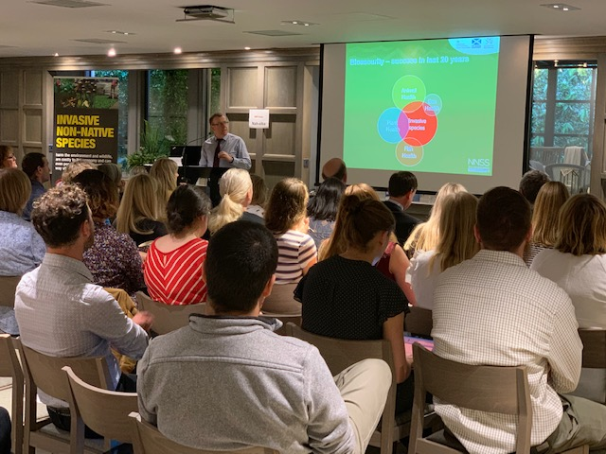

#### Acknowledgements

We would like to thank all our speakers and workshop chairs for their invaluable contributions and Defra for providing the funding for this event. Thanks also to the staff at the Royal Scotsman Hotel, Edinburgh for their professional service and hospitality.