Report pursuant to Article 24 of the Invasive Alien Species Regulation (EU 1143/2014) in Great Britain 2019-2025
This report provides an overview of the information required to be published under Article 24 of the Invasive Alien Species Regulation (EU 1143/2014) for England and Wales and covers the period 2019 to 2025. The previous report (2015-2019) is available on the GB Non-native Species Secretariat (GBNNSS) website.
Contents
1. Description of the surveillance system pursuant to Article 14 2
Recording, Reporting and Maintaining Data 2
Alert Mechanism and Dedicated Surveillance 3
Verification of records in the alert system 5
INNS reporting portal on NBN Atlas Wales 5
2. Description of the official control system pursuant to Article 15 6
The GB Non-native Species Inspectorate (GBNNSI) 6
3. Action plans referred to in Article 13(2) 7
4. Eradication measures taken in accordance with Article 17 8
5. Management measures undertaken in accordance with Article 19 25
6. Permits referred to in Article 8 and the purpose for which they were issued 28
7. Measures taken to inform the public about invasive alien species 29
Alert mechanism 29
Identification Information 30
Awareness raising and encouraging better biosecurity 31
8. Inspections required under Article 8(8) 33
9. Cost of action undertaken to comply with the Regulation 35
Appendix: Measures taken to inform the public about invasive alien species 38
Appendix A: Alert species 38
Appendix B: ID sheets and Alert posters 38
Appendix C: New ID sheets 40

1. Description of the surveillance system pursuant to Article 14
Great Britain has established a surveillance system to determine the presence and distribution of new and established invasive non-native Species of Special Concern. This system includes:
- the development and maintenance of essential partnerships with recording schemes / societies / organisations / the public
- awareness raising activities
- the provision of identification information and reporting tools
- systems and work to improve more effective / efficient reporting of species across taxa and environment (including apps and online tools)
- an alert system for high priority species, as well as dedicated surveillance programmes for specific Species of Special Concern
- a centrally maintained database of non-native species information to support analysis, modelling, distribution mapping etc.
The system is designed to support the early detection of new Species of Special Concern should they arrive in GB (to facilitate a management response), mapping and monitoring of established species and other forms of analysis.

Recording, Reporting and Maintaining Data
The GB Non-native Species Information Portal (GB-NNSIP) (Roy et al 2014), which has been funded by DEFRA, has been the central hub for non-native species recording since 2009. It is led by the UK Centre for Ecology & Hydrology and is a partnership including the Botanical Society of Britain and Ireland, British Trust for Ornithology and the Marine Biological Association alongside a network of people including the volunteer recording schemes and societies hosted by the Biological Records Centre (BRC) and other organisations engaged in sharing information on non-native species (Roy et al. 2014b; Roy et al. 2015).
By working in partnership, the GB-NNSIP has built on the long history of extensive biological recording that is already established in GB and harnesses this to encourage and facilitate the flow of invasive non-native species (INNS) records from a wide range of sources into central databases (Figure 1). While Species of Special Concern are prioritised, the GB-NNSIP is comprehensive, comprising a register of over 3000 non-native species, together with supporting information on country of origin, arrival pathway, establishment status, occurrence within habitats, date of first record, human impact and environmental impact. It is dynamic, being constantly populated with new data and incorporating reporting systems to inform and alert various stakeholders. The GB-NNSIP:
- Increases recording of INNS by raising awareness (presentations, communications including through national media, direct contact with recording schemes / societies / statutory bodies, etc.)
- Encourages INNS recording across taxa and environment.
- Facilitates the recording of INNS through online and back-end technology, apps, etc.
- Provides a central repository for INNS information.
- Can be used to provide analysis, including provision of occurrence and other data to government to support management.
- Established and maintains the alert mechanism (Figure 1).
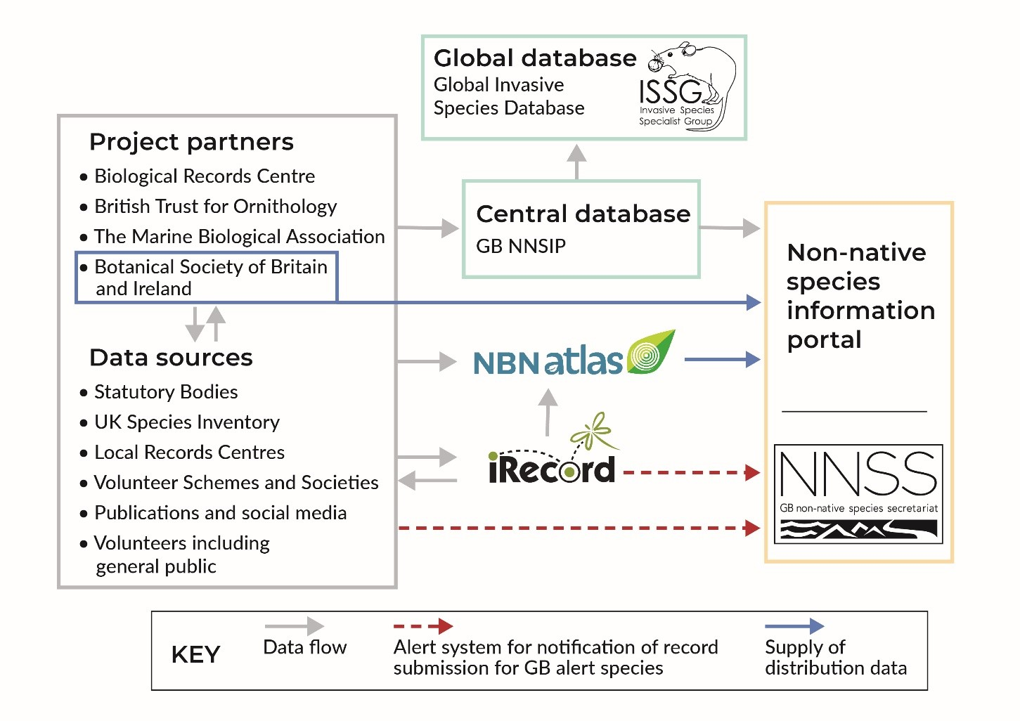
Figure 1. Structure and data flow in the GB-NNSIP

Alert Mechanism and Dedicated Surveillance
The early detection of new non-native species is essential to support effective and efficient management responses. An alert mechanism has been established in GB to support the rapid identification and reporting of Species of Special Concern (as well as other priority species). This includes a range of input methods to facilitate rapid recording, including online forms, apps and an alert email address, as well as extensive systems to maintain and verify alerts as they arrive. The appropriate authorities are automatically informed of reports of high priority species in most cases or manually informed in the case of alerts sent solely through the email system (Figure 2). The system monitors alerts in (effectively) real time, with most high priority reports verified and reported to the authorities in a matter of a few days. For example, the system shows the period from detection to destruction for a Yellow-legged (Asian) Hornet nest in Hampshire was 3 days.
To date the alert mechanism has received over 90,000 reports in total and has been vital in the detection and response to Yellow-legged (Asian) Hornet in particular (Figure 3). Other Species of Special Concern that GB has detected and responded to since 2015 include raccoon (single individual, not considered a wild population), coati and various-leaved watermilfoil (detected before being listed as a Species of Special Concern), among others.
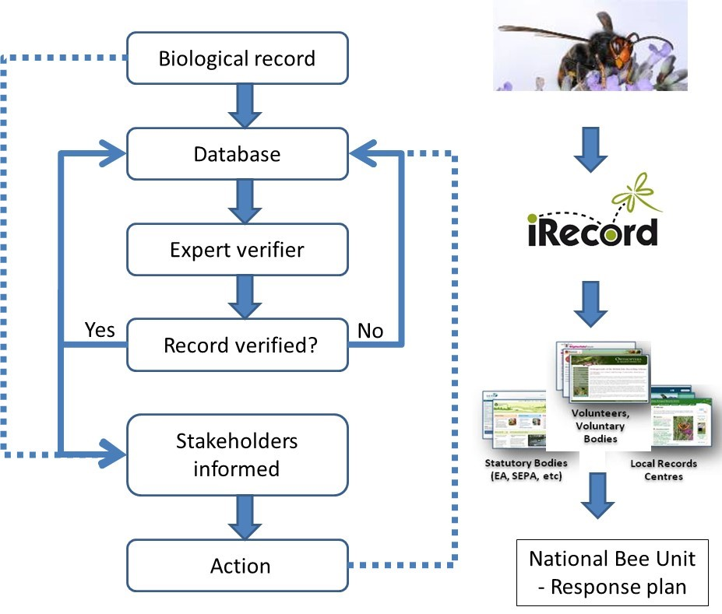
Figure 2. Outline of the alert system in which a biological record is received either by e-mail or within iRecord.

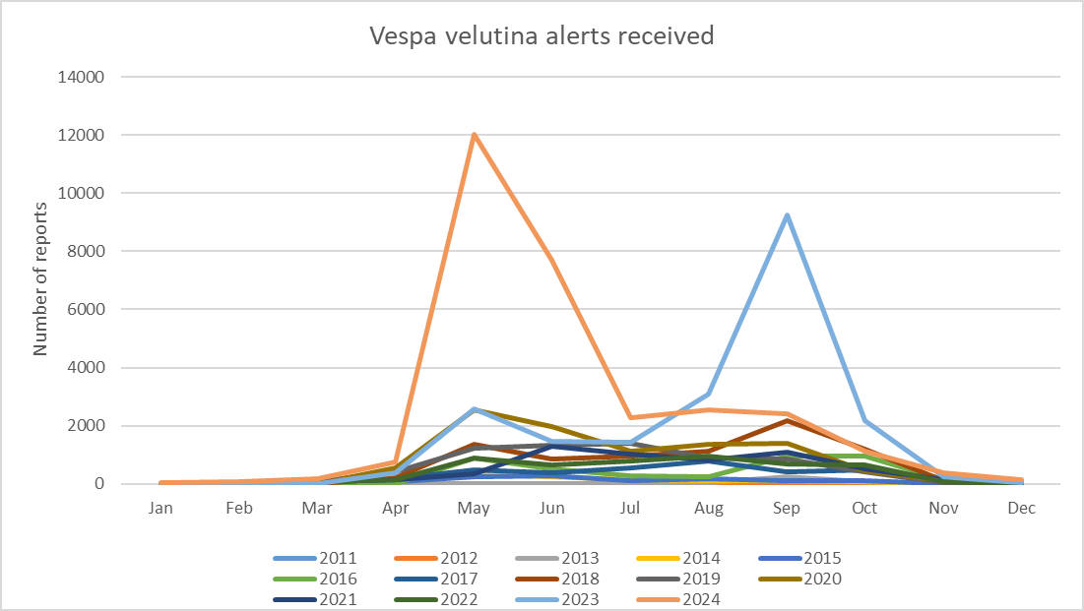
Figure 3. Number of Yellow-legged (Asian) Hornet alerts received each year since 2011.
Early detection and rapid response is particularly important for the Yellow-legged (Asian) Hornet, a Species of Special Concern that can spread extremely rapidly and requires detection at the earliest opportunity to prevent it from establishing in GB. As such, an additional dedicated surveillance system has been developed for this species, using a network of sentinel apiaries. This has involved identifying strategically located beekeepers in areas the Yellow-legged (Asian) Hornet may arrive in GB and providing training, traps and other resources to ensure they detect and report the hornet as soon as it is detected. This too has been essential in GB’s response to this species.

Verification of records in the alert system
The alert system (Figure 2) is promoted through the GB Non-Native Species Secretariat website and links to iRecord, a website for managing wildlife records. The system enables rapid reporting and verification of species considered as a priority for action. On-line capability enables people to register for notification of selected species of interest and ensures rapid data flow to support effective decision-making. The alert system deals with suspected records of Species of Special Concern and also includes species identified as high-risk through horizon scanning (Roy et al. 2014a, Roy et al. 2019).
Any person may report a sighting of an alert species via a range of methods including a dedicated email account (alertnonnative@ceh.ac.uk), a suite of online recording forms and several apps including ‘Asian Hornet Watch’. Suspected sightings of alert species are stored within a central database that provides record details to authorised users, with system notifications automatically sent to registered users when sightings are confirmed or considered plausible. As well as this alert system, there are established links with the NBN Atlas that generates automated notifications when new records of alert species are uploaded to the database. Anyone can register to receive notifications of alert species but additionally reports of sightings of particular concern are forwarded immediately to the Non-Native Species Secretariat and other authorities.

INNS reporting portal on NBN Atlas Wales
In 2018 the Welsh Government commissioned the NBN Atlas Wales to release the Invasive Non-Native Species (INNS) Portal. The INNS Portal supplements the GB NNSIP and its Alerts mechanisms by providing a facility to view and search for INNS specifically of interest to Wales. The INNS Portal includes over 300 terrestrial, freshwater and marine species of interest to Wales and allows species occurrences and distribution to be searched for and downloaded individually or collectively by list. Species include those listed under EU and national legislation and those of policy and practical interest, including those identified as Wales Priority Invasive Non-Native Species for Action by the Wales Biodiversity Partnership INNS Group.
The Wales Biodiversity Partnership INNS Group maintains a list of Priority Species for Action in Wales. Species are listed under three categories – prevention priority species (those not yet in the wild but likely to arrive), management priority species (those present in the wild in low numbers) and long-term management priority species (those established in the wild). The Welsh Government has also produced Priority Monitoring and Surveillance lists for Marine INNS.

2. Description of the official control system pursuant to Article 15
The official control system has been implemented by the Invasive Alien Species (Enforcement and Permitting) Order 2019 (The IAS Order). The IAS Order ensures that the Regulation is effectively enforced at the UK border, identifies the competent authorities responsible for the official controls, and puts in place supporting provisions. For example, it makes provision for live specimens of Species of Special Concern to be seized at the UK border by Border Force officials. There are arrangements in place for detained consignments to be passed to the Animal and Plant Health Agency who will arrange for specimens to be handled appropriately. Animals will not be euthanised in all cases; where appropriate, arrangements may be made for their re-export or transfer to an appropriate facility, in discussion with their owners. The IAS Order provides for recovery of enforcement-related costs from importers by enforcement authorities.

The GB Non-native Species Inspectorate (GBNNSI)
The Inspectorate was established in April 2021 and aims to ensure that existing legislation (for example, on the keeping of Species of Special Concern) is better understood by stakeholders and enforced where necessary. Since its establishment it has carried out over 3,000 inspections across 14 sectors such as: garden centres, zoos, animal rescue centres, pet shops, angling, boating, shipping containers, falconry, and online sales. The Inspectorate has found significant levels of non-compliance with legislation (overall 11% on systematic inspections). More than 500 online listings of banned species have been detected, and 19 animals have been seized since April 2023.

3. Action plans referred to in Article 13(2)
In May 2019, the UK published a comprehensive analysis of pathways of unintentional introduction and spread of invasive alien species, which identified a total of 36 pathways of introduction. Six of these were prioritised for pathway action plans (PAPs): hull fouling, horticulture escapes, contaminants of ornamental plants, ballast water, stowaways on fishing equipment and zoos.
Five PAPs have been drafted and approved by the GB Non-native Species Programme Board; Angling Pathway PAP, Horticulture Pathway PAP, Pet Pathway PAP, Recreational Boating Pathway PAP and Zoos Pathway PAP. The draft PAPs are available on the GB Non-native Species Secretariat (GBNNSS) website. All PAPs were developed and approved by working groups comprising a wide range of relevant government and non-government stakeholders. The PAPs are due to be put to public consultation shortly, with a view to publishing the final versions by the end of 2025.
The requirement to develop a PAP for Ballast water has been addressed by the UK acceding to the International Ballast Water Management Convention (“the BWM Convention”). The Maritime and Coastguard Agency (MCA) carried out a public consultation from 24th March to 16th June 2021 on the draft Merchant Shipping (Control and Management of Ships’ Ballast Water and Sediments) Regulations 2021. These regulations have since been made as The Merchant Shipping (Control and Management of Ships’ Ballast Water and Sediments) Regulations 2022. The Regulations were produced in order to implement into UK law the requirements of the International Convention for the Control and Management of Ships’ Ballast Water and Sediments 2004. This formed part of the package to allow the UK to accede to the BWM Convention in May 2022. Full consultation reports can be found here: Consultation on draft regulations for the control and management of ships’ ballast water and sediments - GOV.UK.

4. Eradication measures taken in accordance with Article 17
Scientific name | Common name | Population number | Start date of measure | End date of measure | Part of the territory | Method(s) used | Effectiveness of the measure(s) | Negative impacts observed on other species
Nyctereutes procyonoides | Raccoon dog | Population #1 | Jul 2020 | Jul 2020 | Wales | Trapping | Eradicated | None
Procyon lotor | Raccoon | Population #1 | Jan 2024 | Feb 2024 | Sunderland, England | Trapping | Recaptured | None
Procyon lotor | Raccoon | Population #2 | Apr 2023 | Apr 2023 | Derbyshire, England | Trapping | Unsuccessful | None
Pseudorasbora parva | Topmouth gudgeon | Population #1 | Apr 2022 | Ongoing | Multiple sites, Wales | Chemical, then Biocontrol | Abandoned Not yet started | Not known
Vespa velutina nigrithorax | Yellow-legged (Asian) Hornet | Population #1 | Sep 2019 | Oct 2019 | West Midlands, England | Chemical | Eradicated | None
Vespa velutina nigrithorax | Yellow-legged (Asian) Hornet | Population #2 | Oct 2019 | Nov 2019 | South West, England | Chemical | Eradicated | None
Vespa velutina nigrithorax | Yellow-legged (Asian) Hornet | Population #3 | Oct 2019 | Nov 2019 | South West, England | Chemical | Eradicated | None
Vespa velutina nigrithorax | Yellow-legged (Asian) Hornet | Population #4 | Sep 2020 | Oct 2020 | South East, England | Chemical | Eradicated | None
Vespa velutina nigrithorax | Yellow-legged (Asian) Hornet | Population #5 | Oct 2021 | Nov 2021 | South East, England | Chemical | Eradicated | None
Vespa velutina nigrithorax | Yellow-legged (Asian) Hornet | Population #6 | Oct 2021 | Nov 2021 | South East, England | Chemical | Eradicated | None
Vespa velutina nigrithorax | Yellow-legged (Asian) Hornet | Population #7 | Sep 2022 | Oct 2022 | South East, England | Chemical | Eradicated | None
Vespa velutina nigrithorax | Yellow-legged (Asian) Hornet | Population #8 | Jun 2023 | Jul 2023 | South East, England | Chemical | Eradicated | None
Vespa velutina nigrithorax | Yellow-legged (Asian) Hornet | Population #9 | Jul 2023 | Aug 2023 | South East, England | Chemical | Eradicated | None
Vespa velutina nigrithorax | Yellow-legged (Asian) Hornet | Population #10 | Jul 2023 | Aug 2023 | South East, England | Chemical | Eradicated | None
Vespa velutina nigrithorax | Yellow-legged (Asian) Hornet | Population #11 | Jul 2023 | Aug 2023 | South West, England | Chemical | Eradicated | None
Vespa velutina nigrithorax | Yellow-legged (Asian) Hornet | Population #12 | Jul 2023 | Aug 2023 | South West, England | Chemical | Eradicated | None
Vespa velutina nigrithorax | Yellow-legged (Asian) Hornet | Population #13 | Aug 2023 | Sep 2023 | South East, England | Chemical | Eradicated | None
Vespa velutina nigrithorax | Yellow-legged (Asian) Hornet | Population #14 | Aug 2023 | Sep 2023 | South East, England | Chemical | Eradicated | None
Vespa velutina nigrithorax | Yellow-legged (Asian) Hornet | Population #15 | Aug 2023 | Sep 2023 | South West, England | Chemical | Eradicated | None
Vespa velutina nigrithorax | Yellow-legged (Asian) Hornet | Population #16 | Aug 2023 | Sep 2023 | South East, England | Chemical | Eradicated | None
Vespa velutina nigrithorax | Yellow-legged (Asian) Hornet | Population #17 | Aug 2023 | Sep 2023 | South East, England | Chemical | Eradicated | None
Vespa velutina nigrithorax | Yellow-legged (Asian) Hornet | Population #18 | Aug 2023 | Sep 2023 | South West, England | Chemical | Eradicated | None
Vespa velutina nigrithorax | Yellow-legged (Asian) Hornet | Population #19 | Aug 2023 | Sep 2023 | South East, England | Chemical | Eradicated | None
Vespa velutina nigrithorax | Yellow-legged (Asian) Hornet | Population #20 | Aug 2023 | Sep 2023 | South East, England | Chemical | Eradicated | None
Vespa velutina nigrithorax | Yellow-legged (Asian) Hornet | Population #21 | Aug 2023 | Sep 2023 | South East, England | Chemical | Eradicated | None
Vespa velutina nigrithorax | Yellow-legged (Asian) Hornet | Population #22 | Aug 2023 | Oct 2023 | South East, England | Chemical | Eradicated | None
Vespa velutina nigrithorax | Yellow-legged (Asian) Hornet | Population #23 | Aug 2023 | Oct 2023 | South East, England | Chemical | Eradicated | None
Vespa velutina nigrithorax | Yellow-legged (Asian) Hornet | Population #24 | Aug 2023 | Oct 2023 | South East, England | Chemical | Eradicated | None
Vespa velutina nigrithorax | Yellow-legged (Asian) Hornet | Population #25 | Aug 2023 | Oct 2023 | South East, England | Chemical | Eradicated | None
Vespa velutina nigrithorax | Yellow-legged (Asian) Hornet | Population #26 | Aug 2023 | Oct 2023 | South East, England | Chemical | Eradicated | None
Vespa velutina nigrithorax | Yellow-legged (Asian) Hornet | Population #27 | Aug 2023 | Oct 2023 | South East, England | Chemical | Eradicated | None
Vespa velutina nigrithorax | Yellow-legged (Asian) Hornet | Population #28 | Aug 2023 | Oct 2023 | South East, England | Chemical | Eradicated | None
Vespa velutina nigrithorax | Yellow-legged (Asian) Hornet | Population #29 | Aug 2023 | Sep 2023 | South East, England | Chemical | Eradicated | None
Vespa velutina nigrithorax | Yellow-legged (Asian) Hornet | Population #30 | Aug 2023 | Sep 2023 | South East, England | Chemical | Eradicated | None
Vespa velutina nigrithorax | Yellow-legged (Asian) Hornet | Population #31 | Aug 2023 | Sep 2023 | South East, England | Chemical | Eradicated | None
Vespa velutina nigrithorax | Yellow-legged (Asian) Hornet | Population #32 | Aug 2023 | Sep 2023 | South East, England | Chemical | Eradicated | None
Vespa velutina nigrithorax | Yellow-legged (Asian) Hornet | Population #33 | Aug 2023 | Sep 2023 | South East, England | Chemical | Eradicated | None
Vespa velutina nigrithorax | Yellow-legged (Asian) Hornet | Population #34 | Aug 2023 | Sep 2023 | South East, England | Chemical | Eradicated | None
Vespa velutina nigrithorax | Yellow-legged (Asian) Hornet | Population #35 | Aug 2023 | Sep 2023 | South East, England | Chemical | Eradicated | None
Vespa velutina nigrithorax | Yellow-legged (Asian) Hornet | Population #36 | Aug 2023 | Sep 2023 | South East, England | Chemical | Eradicated | None
Vespa velutina nigrithorax | Yellow-legged (Asian) Hornet | Population #37 | Aug 2023 | Sep 2023 | South East, England | Chemical | Eradicated | None
Vespa velutina nigrithorax | Yellow-legged (Asian) Hornet | Population #38 | Aug 2023 | Sep 2023 | South East, England | Chemical | Eradicated | None
Vespa velutina nigrithorax | Yellow-legged (Asian) Hornet | Population #39 | Aug 2023 | Sep 2023 | South East, England | Chemical | Eradicated | None
Vespa velutina nigrithorax | Yellow-legged (Asian) Hornet | Population #40 | Aug 2023 | Sep 2023 | South East, England | Chemical | Eradicated | None
Vespa velutina nigrithorax | Yellow-legged (Asian) Hornet | Population #41 | Aug 2023 | Sep 2023 | South East, England | Chemical | Eradicated | None
Vespa velutina nigrithorax | Yellow-legged (Asian) Hornet | Population #42 | Aug 2023 | Sep 2023 | South East, England | Chemical | Eradicated | None
Vespa velutina nigrithorax | Yellow-legged (Asian) Hornet | Population #43 | Aug 2023 | Sep 2023 | South East, England | Chemical | Eradicated | None
Vespa velutina nigrithorax | Yellow-legged (Asian) Hornet | Population #44 | Aug 2023 | Sep 2023 | South East, England | Chemical | Eradicated | None
Vespa velutina nigrithorax | Yellow-legged (Asian) Hornet | Population #45 | Aug 2023 | Sep 2023 | South East, England | Chemical | Eradicated | None
Vespa velutina nigrithorax | Yellow-legged (Asian) Hornet | Population #46 | Aug 2023 | Sep 2023 | South East, England | Chemical | Eradicated | None
Vespa velutina nigrithorax | Yellow-legged (Asian) Hornet | Population #47 | Aug 2023 | Sep 2023 | South East, England | Chemical | Eradicated | None
Vespa velutina nigrithorax | Yellow-legged (Asian) Hornet | Population #48 | Aug 2023 | Sep 2023 | South East, England | Chemical | Eradicated | None
Vespa velutina nigrithorax | Yellow-legged (Asian) Hornet | Population #49 | Aug 2023 | Sep 2023 | South East, England | Chemical | Eradicated | None
Vespa velutina nigrithorax | Yellow-legged (Asian) Hornet | Population #50 | Sep 2023 | Oct 2023 | South East, England | Chemical | Eradicated | None
Vespa velutina nigrithorax | Yellow-legged (Asian) Hornet | Population #51 | Sep 2023 | Oct 2023 | South East, England | Chemical | Eradicated | None
Vespa velutina nigrithorax | Yellow-legged (Asian) Hornet | Population #52 | Sep 2023 | Oct 2023 | South East, England | Chemical | Eradicated | None
Vespa velutina nigrithorax | Yellow-legged (Asian) Hornet | Population #53 | Sep 2023 | Oct 2023 | South East, England | Chemical | Eradicated | None
Vespa velutina nigrithorax | Yellow-legged (Asian) Hornet | Population #54 | Sep 2023 | Oct 2023 | South East, England | Chemical | Eradicated | None
Vespa velutina nigrithorax | Yellow-legged (Asian) Hornet | Population #55 | Sep 2023 | Oct 2023 | East, England | Chemical | Eradicated | None
Vespa velutina nigrithorax | Yellow-legged (Asian) Hornet | Population #56 | Sep 2023 | Oct 2023 | South East, England | Chemical | Eradicated | None
Vespa velutina nigrithorax | Yellow-legged (Asian) Hornet | Population #57 | Sep 2023 | Oct 2023 | South East, England | Chemical | Eradicated | None
Vespa velutina nigrithorax | Yellow-legged (Asian) Hornet | Population #58 | Sep 2023 | Oct 2023 | North, England | Chemical | Eradicated | None
Vespa velutina nigrithorax | Yellow-legged (Asian) Hornet | Population #59 | Sep 2023 | Oct 2023 | North, England | Chemical | Eradicated | None
Vespa velutina nigrithorax | Yellow-legged (Asian) Hornet | Population #60 | Sep 2023 | Oct 2023 | South East, England | Chemical | Eradicated | None
Vespa velutina nigrithorax | Yellow-legged (Asian) Hornet | Population #61 | Sep 2023 | Oct 2023 | South East, England | Chemical | Eradicated | None
Vespa velutina nigrithorax | Yellow-legged (Asian) Hornet | Population #62 | Sep 2023 | Oct 2023 | South East, England | Chemical | Eradicated | None
Vespa velutina nigrithorax | Yellow-legged (Asian) Hornet | Population #63 | Sep 2023 | Oct 2023 | South East, England | Chemical | Eradicated | None
Vespa velutina nigrithorax | Yellow-legged (Asian) Hornet | Population #64 | Sep 2023 | Oct 2023 | South East, England | Chemical | Eradicated | None
Vespa velutina nigrithorax | Yellow-legged (Asian) Hornet | Population #65 | Sep 2023 | Oct 2023 | South East, England | Chemical | Eradicated | None
Vespa velutina nigrithorax | Yellow-legged (Asian) Hornet | Population #66 | Sep 2023 | Oct 2023 | South East, England | Chemical | Eradicated | None
Vespa velutina nigrithorax | Yellow-legged (Asian) Hornet | Population #67 | Sep 2023 | Oct 2023 | South East, England | Chemical | Eradicated | None
Vespa velutina nigrithorax | Yellow-legged (Asian) Hornet | Population #68 | Sep 2023 | Oct 2023 | North, England | Chemical | Eradicated | None
Vespa velutina nigrithorax | Yellow-legged (Asian) Hornet | Population #69 | Sep 2023 | Oct 2023 | South East, England | Chemical | Eradicated | None
Vespa velutina nigrithorax | Yellow-legged (Asian) Hornet | Population #70 | Sep 2023 | Oct 2023 | South East, England | Chemical | Eradicated | None
Vespa velutina nigrithorax | Yellow-legged (Asian) Hornet | Population #71 | Sep 2023 | Oct 2023 | South East, England | Chemical | Eradicated | None
Vespa velutina nigrithorax | Yellow-legged (Asian) Hornet | Population #72 | Sep 2023 | Oct 2023 | South East, England | Chemical | Eradicated | None
Vespa velutina nigrithorax | Yellow-legged (Asian) Hornet | Population #73 | Oct 2023 | Nov 2023 | South East, England | Chemical | Eradicated | None
Vespa velutina nigrithorax | Yellow-legged (Asian) Hornet | Population #74 | Oct 2023 | Nov 2023 | South East, England | Chemical | Eradicated | None
Vespa velutina nigrithorax | Yellow-legged (Asian) Hornet | Population #75 | Oct 2023 | Nov 2023 | South East, England | Chemical | Eradicated | None
Vespa velutina nigrithorax | Yellow-legged (Asian) Hornet | Population #76 | Oct 2023 | Nov 2023 | South East, England | Chemical | Eradicated | None
Vespa velutina nigrithorax | Yellow-legged (Asian) Hornet | Population #77 | Oct 2023 | Nov 2023 | South East, England | Chemical | Eradicated | None
Vespa velutina nigrithorax | Yellow-legged (Asian) Hornet | Population #78 | Oct 2023 | Nov 2023 | South East, England | Chemical | Eradicated | None
Vespa velutina nigrithorax | Yellow-legged (Asian) Hornet | Population #79 | Nov 2023 | Nov 2023 | South East, England | Chemical | Eradicated | None
Vespa velutina nigrithorax | Yellow-legged (Asian) Hornet | Population #80 | Nov 2023 | Nov 2023 | South East, England | Chemical | Eradicated | None
Vespa velutina nigrithorax | Yellow-legged (Asian) Hornet | Population #81 | May 2024 | Jun 2024 | South East, England | Chemical | Eradicated | None
Vespa velutina nigrithorax | Yellow-legged (Asian) Hornet | Population #82 | Aug 2024 | Oct 2024 | South East, England | Chemical | Eradicated | None
Vespa velutina nigrithorax | Yellow-legged (Asian) Hornet | Population #83 | Aug 2024 | Sep 2024 | South East, England | Chemical | Eradicated | None
Vespa velutina nigrithorax | Yellow-legged (Asian) Hornet | Population #84 | Aug 2024 | Sep 2024 | South East, England | Chemical | Eradicated | None
Vespa velutina nigrithorax | Yellow-legged (Asian) Hornet | Population #85 | Aug 2024 | Sep 2024 | South East, England | Chemical | Eradicated | None
Vespa velutina nigrithorax | Yellow-legged (Asian) Hornet | Population #86 | Aug 2024 | Sep 2024 | South East, England | Chemical | Eradicated | None
Vespa velutina nigrithorax | Yellow-legged (Asian) Hornet | Population #87 | Aug 2024 | Sep 2024 | South East, England | Chemical | Eradicated | None
Vespa velutina nigrithorax | Yellow-legged (Asian) Hornet | Population #88 | Sep 2024 | Oct 2024 | South East, England | Chemical | Eradicated | None
Vespa velutina nigrithorax | Yellow-legged (Asian) Hornet | Population #89 | Sep 2024 | Oct 2024 | South East, England | Chemical | Eradicated | None
Vespa velutina nigrithorax | Yellow-legged (Asian) Hornet | Population #90 | Sep 2024 | Oct 2024 | South East, England | Chemical | Eradicated | None
Vespa velutina nigrithorax | Yellow-legged (Asian) Hornet | Population #91 | Sep 2024 | Oct 2024 | South East, England | Chemical | Eradicated | None
Vespa velutina nigrithorax | Yellow-legged (Asian) Hornet | Population #92 | Sep 2024 | Oct 2024 | South East, England | Chemical | Eradicated | None
Vespa velutina nigrithorax | Yellow-legged (Asian) Hornet | Population #93 | Sep 2024 | Oct 2024 | South East, England | Chemical | Eradicated | None
Vespa velutina nigrithorax | Yellow-legged (Asian) Hornet | Population #94 | Sep 2024 | Oct 2024 | South East, England | Chemical | Eradicated | None
Vespa velutina nigrithorax | Yellow-legged (Asian) Hornet | Population #95 | Sep 2024 | Oct 2024 | South East, England | Chemical | Eradicated | None
Vespa velutina nigrithorax | Yellow-legged (Asian) Hornet | Population #96 | Sep 2024 | Oct 2024 | South East, England | Chemical | Eradicated | None
Vespa velutina nigrithorax | Yellow-legged (Asian) Hornet | Population #97 | Sep 2024 | Oct 2024 | South East, England | Chemical | Eradicated | None
Vespa velutina nigrithorax | Yellow-legged (Asian) Hornet | Population #98 | Sep 2024 | Oct 2024 | South East, England | Chemical | Eradicated | None
Vespa velutina nigrithorax | Yellow-legged (Asian) Hornet | Population #99 | Sep 2024 | Oct 2024 | South East, England | Chemical | Eradicated | None
Vespa velutina nigrithorax | Yellow-legged (Asian) Hornet | Population #100 | Oct 2024 | Nov 2024 | South East, England | Chemical | Eradicated | None
Vespa velutina nigrithorax | Yellow-legged (Asian) Hornet | Population #101 | Oct 2024 | Nov 2024 | South East, England | Chemical | Eradicated | None
Vespa velutina nigrithorax | Yellow-legged (Asian) Hornet | Population #102 | Nov 2024 | Nov 2024 | South East, England | Chemical | Eradicated | None
Vespa velutina nigrithorax | Yellow-legged (Asian) Hornet | Population #103 | Nov 2024 | Nov 2024 | South East, England | Chemical | Eradicated | None
Vespa velutina nigrithorax | Yellow-legged (Asian) Hornet | Population #104 | Nov 2024 | Nov 2024 | South East, England | Chemical | Eradicated | None

5. Management measures undertaken in accordance with Article 19
Scientific name | Common name | Start date of measure(s) | End date of measure(s) | Objective of the measure(s) | Part of the territory | Method(s) used | Effectiveness of the measure(s) | Negative impacts observed on other species
Alopochen aegyptiacus | Egyptian goose | Jun 2019 | Jun 2025 | Control | East of England | Mechanical and physical | Population increasing | None
Elodea nuttallii | Nuttall's waterweed | Jun 2019 | Jun 2025 | Containment | Great Britain | Mechanical and physical | Population increasing | None
Eriocheir sinensis | Chinese mitten crab | Jun 2019 | Jun 2025 | Containment | England and Wales | Mechanical and physical | Population increasing | None
Gunnera tinctoria | Chilean rhubarb | Jun 2019 | Jun 2025 | Containment | Great Britain | Chemical, mechanical, and physical | Population increasing | None
Heracleum mantegazzianum | Giant hogweed | Jun 2019 | Jun 2025 | Control | Great Britain | Chemical, mechanical, and physical | Population increasing | None
Hydrocotyle ranunculoides | Floating pennywort | Jun 2019 | Jun 2025 | Control | England and Wales | Chemical, mechanical, and physical | Population increasing | None
Impatiens glandulifera | Himalayan balsam | Jun 2019 | Jun 2025 | Control | Great Britain | Biological, chemical, mechanical and physical | Population increasing | None
Lagarosiphon major | Curly waterweed | Jun 2019 | Jun 2025 | Containment | Great Britain | Mechanical and physical | Population increasing | None
Lysichiton americanus | American skunk cabbage | Jun 2019 | Jun 2025 | Control | Great Britain | Chemical, mechanical, and physical | Population increasing | None
Muntiacus reevesi | Muntjac deer | Jun 2019 | Jun 2025 | Control | England and Wales | Mechanical and physical | Population increasing | None
Oxyura jamaicensis | Ruddy duck | Jun 2019 | Jun 2025 | Eradication | England | Mechanical and physical | Population decreasing | None
Pacifastacus leniusculus | Signal crayfish | Jun 2019 | Jun 2025 | Containment | England and Wales | Chemical, mechanical, and physical | Population increasing | None
Sciurus carolinensis | Grey squirrel | Jun 2019 | Jun 2025 | Control | Great Britain | Mechanical and physical | Population increasing | None
Trachemys scripta | Red-eared, yellow-bellied and Cumberland sliders | Jun 2019 | Jun 2025 | Control | Great Britain | Mechanical and physical | Population stable | None
Myriophyllum aquaticum | Parrot's feather | Jun 2019 | Jun 2025 | Containment | Great Britain | Mechanical and physical | Population increasing | None
Arthurdendyus triangulatus | New Zealand flatworm | Jun 2019 | Jun 2025 | Containment | Great Britain | Mechanical and physical | Population increasing | None
Lepomis gibbosus | Pumpkinseed | Jun 2019 | Jun 2025 | Containment | England | Mechanical and physical | Population stable | None
Ailanthus altissima | Tree of heaven | Jun 2019 | Jun 2025 | Containment | England | Mechanical and physical | Population increasing | None

6. Permits referred to in Article 8 and the purpose for which they were issued
The details of permits issued for the reporting period are available on the GB Non-native Species Secretariat (GBNNSS) website.

7. Measures taken to inform the public about invasive alien species
Measures taken to inform the public about the presence of invasive alien species and actions to be taken by citizens are set out below under the following headings:
- Alert mechanism: designed to raise awareness and encourage reporting of high priority species, in particular the Yellow-legged (Asian) Hornet
- Identification information for a range of species, including 26 Species of Special Concern.
- Awareness raising and encouraging better biosecurity.

Alert mechanism
In GB, a number of high priority invasive non-native species (INNS), including 13 Species of Special Concern, have been classified as alert species (Appendix A). To support surveillance of these species, citizens are encouraged to look out for and report any suspected sightings. The alert pages of the GB Non-native Species Secretariat (GBNNSS) website contain information, awareness raising materials including “alert” posters for seven species (including four Species of Special Concern: Ludwigia spp, Nyctereutes procyonoides, and Vespa velutina, see Appendix B), and links to recording pages for these species.
The GBNNSS works closely with a wide range of stakeholders with large public audiences, including Local Action Groups, environmental NGOs, and other organisations, to raise awareness of alert species. When a new priority species is detected, the network is informed and provided with materials which they disseminate amongst their volunteers, members, and visitors.

Case study: Yellow-legged (Asian) Hornet, Vespa velutina
Efforts have been concentrated on Yellow-legged (Asian) Hornet. Citizens are asked to report suspected sightings to the GB alert system through:
- a dedicated online recording page
- a free smartphone app for iPhone and Android, which also provides identification guidance
- a general “alert” email address (alertnonnative@ceh.ac.uk).
Records are triaged and any plausible sightings passed on to the National Bee Unit to follow up. Examples of activities since 2019 to raise awareness of the general public and inform them of new sightings include:
- disseminating over 179,000 awareness raising materials, including alert posters, identification sheets, and wallet sized ID cards
- APHA developing a gold medal award winning exhibit at Chelsea Flower Show in May 2024 to highlight the threat of Yellow-legged (Asian) Hornet, attended by over 45,000 visitors and resulting in a 700% increase in app downloads compared to the previous week
- DEFRA Press Office issuing national press releases to the UK media
- writing to organisations, including local councils, gardens, and environmental NGOs, in outbreak areas to ask them to display awareness-raising posters at their sites and share information with visitors
The GBNNSS also works closely with stakeholders to assist with awareness raising. For example, during the 2024 outbreak it regularly wrote to over 130 organisations (both senior and technical representatives) to alert them to new sightings and ask for their assistance with awareness raising amongst their members and networks.
All communications and press releases included guidance on identification and asked the public to report suspected sightings immediately.
As a result of this the number of records received has increased substantially each year since 2019 (see Figure 1). The number of positive records is still very low, since 2019 there have been 132 confirmed sightings of Asian hornet in GB.
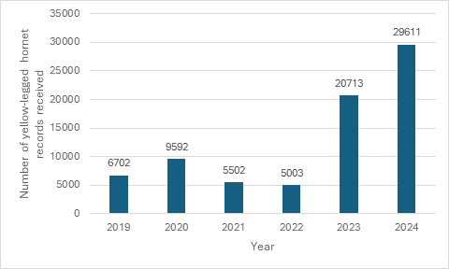
Figure 1. Number of Yellow-legged (Asian) Hornet records received per year from 2019 – 2024.

Identification Information
In 2024 the GBNNSS developed two posters and pop-up banners to raise awareness of Species of Special Concern:
- Poster with non-native animals of Special Concern
- Poster with non-native plants of Special Concern
1,000 hard copy posters have been disseminated to stakeholders to support awareness raising, and the banners are used at meetings and events, including the annual Stakeholder Forum in June 2024.
ID guides have been developed for 76 species, including 26 Species of Special Concern (Appendix B). 29 new ID sheets are currently in development, including a further nine Species of Special Concern (Appendix C).
ID sheets are available to download from the GBNNSS website and provided free to stakeholders to assist a wide range of citizens. Since 2019 approximately 106,400 hard copy ID sheets have been disseminated (including 103,000 Yellow-legged (Asian) Hornet ID sheets).

Awareness raising and encouraging better biosecurity
In GB there are country level working groups to help identify priorities that are relevant at a country scale. Each of the country groups includes representatives from the public, private and third sector who promote local, regional and national action, promote best practice and legislative requirements, encourage recording, and dissemination of information and raise awareness of INNS and their impacts amongst their membership organisations.
The GBNNSS has two awareness raising campaigns to improve awareness and biosecurity among key groups - Be Plant Wise and Check Clean Dry - supported by funding from water companies through the Aquatic Biosecurity Partnership project, and leads an annual week of public awareness raising, Invasive Species Week. GBNNSS are also working with the pet sector to develop an awareness raising campaign for pet owners in GB, to prevent new non-native animals, including Species of Special Concern, from becoming established in the wild.
- Be Plant Wise aims to inform gardeners and pond owners of the potential impact of invasive aquatic plants, including Ludwigia spp, Hydrocotyle ranunculoides, and Myriophyllum aquaticum, listed as Species of Special Concern. The campaign provides guidance on actions citizens should take to reduce the risk of spreading these and other plant species in the wild, such as disposing of plants responsibly. In 2020 the GBNNSS updated and relaunched Be Plant Wise in partnership with the horticulture industry. Since 2019, with the help of partners, it has:
  - disseminated over 16,000 Be Plant Wise materials to gardeners, professional horticulturalists, and plant retailers who have displayed them to customers
  - advertised the campaign through key gardening media, including 7 magazines with a total of 1.8 million copies purchased
  - attended eight large horticultural events to promote the campaign to gardeners and the horticulture industry

- Check Clean Dry aims to raise awareness of invasive aquatic species and their impacts, and asks recreational water users (anglers, boaters, canoeists and kayakers in particular) to check, clean, and dry their equipment after leaving the water to prevent the spread of invasive aquatic species.
The campaign was relaunched in 2019 in partnership with key partners including the Angling Trust, Royal Yachting Association and Paddle UK, who continue to promote the guidance and materials to their membership of clubs and individuals.
Since 2019, with the help of partners, the GBNNSS has disseminated over 111,000 awareness raising materials to recreational water users, including over 2,000 permanent biosecurity signs which clubs have installed at waterbodies to encourage visitors to follow the campaign guidance.
The GBNNSS has continued to hold an annual summer border biosecurity campaign, asking recreational water users travelling abroad to ensure their kit is clean and dry before using it again in the UK. Since 2019 this has included 92 posters displayed at key ports with links to the continent, two adverts in Easyjet onboard magazines, and a series of adverts in specialist angling and sailing magazines, their websites, social media and emails to subscribers.
Other activities the GBNNSS has commissioned since 2019 to encourage better biosecurity include temporary biosecurity / washdown stations at 15 large aquatic sporting competitions, to reduce the risk of transmission of invasive aquatic species and raise awareness of Check Clean Dry.
- Invasive Species Week is an annual initiative involving organisations such as environmental NGOs, industry and Local Action Groups, intended to raise public awareness of INNS, their impacts and what citizens can do to help. Species of Special Concern have been featured in awareness raising materials and citizens asked to report sightings and follow good biosecurity practice to prevent their spread. Engagement since 2019:
  - 2019: over 320 organisations involved and 93 events held.
  - 2020: cancelled due to Covid-19.
  - 2021: over 265 organisations involved and 34 events held.
  - 2022: over 260 organisations involved and 92 events held.
  - 2023: over 260 organisations involved and 73 events held.
  - 2024: over 200 organisations involved and 75 events held.

Biosecurity
A range of online freely available e-learning modules have been produced to provide an introduction to non-native species, and how to identify them, including five on biosecurity. Current e-learning modules include:
- Module 1. Introduction to Invasive Non-native Species
- Module 2a Introduction to Identification and Recording
- Module 2b Identification of invasive freshwater plants
- Module 2c Identification of invasive freshwater invertebrates
- Module 2d Identification of invasive riparian plants
- Module 3. Biosecurity
- Module 4a Biosecurity for the Overseas Territories
- Module 4b Biosecurity Inspections for the Overseas Territories
- Module 5 Biosecurity for the Water Industry
- Biosecurity for Universities, Colleges, Field and Research Centres (developed by the University of Leeds)

8. Inspections required under Article 8(8)
Inspections required under Article 8(8) are undertaken by the GB Non-native Species Inspectorate (GBNNSI). The GBNNSI’s target for inspections of permitted establishments is 52 annually for England and Wales. Inspections under Article 8(8) commenced in 2024, and summary details are provided below.

Total number of permitted establishments: 103.

Year | Purpose of permit | Number of establishments subjected to the inspections | Number or volume of permitted specimens corresponding to the permits held by the inspected establishment | Number of inspected establishments deemed non-compliant with the conditions set out in the permits | Number or volume of permitted specimens corresponding to the permits held by the inspected establishments deemed non-compliant with the conditions set out in the permits
2024/2025 | Ex-situ conservation | 23 | 139 specimens | 13 | Data not available (in some cases, non-compliance was for issues like animals having bred, or non-permitted specimens found, which would make this data misleading)
2024/2025 | Research | 4 | 131 specimens | 1 | Data not available (in some cases, non-compliance was for issues like animals having bred, or non-permitted specimens found, which would make this data misleading)

9. Cost of action undertaken to comply with the Regulation
Collated costs for complying with the Regulation across GB are not available; however, they are likely to be significant. Examples of indicative costs for compliance with the regulation covering Species of Special Concern and wider invasive non-native species, where available, are provided below.
Prevention:
- The main measures for prevention in GB are undertaken by the GB Non- native Species Inspectorate (GBNNSI) and GB Non-native Species Secretariat (GBNNSS), with a focus on raising awareness and working with stakeholders to promote better biosecurity on priority pathways.

- Since the start of the reporting period, the total cost of GBNNSI is £3.44M, funded by DEFRA, and the Welsh and Scottish Governments. The GBNNSS contributes across a range of INNS work, including running the risk analysis mechanism in GB, with costs of approximately £90k per annum.

- Since the start of the reporting period, GBNNSS has spent £616k on the Check Clean Dry and Be Plant Wise awareness raising campaigns, funded partially by water companies through the Aquatic Biosecurity Partnership (£744k). Additional costs, such as staff time (both government and non-government) and a wide range of associated materials, events and activities, are unavailable.

- In Wales, the Welsh Government has provided more than £500k between 2020-2024 to fund the WaREN project, which seeks to develop a framework for action to tackle invasive species impacts on the environment, economy and wellbeing of the people in Wales.

Early detection
- The main mechanism for delivering early detection in GB is the Non-native Species Information Portal (NNSIP), which has received a total of £899,082 since the start of the reporting period. Additional costs for activities such as recording in the field, the maintenance of recording schemes and societies, the maintenance of the Yellow-legged (Asian) Hornet sentinel apiary network and other relevant biological recording systems, are not available.

Eradication
- GBNNSS has estimated, based on the available information, the costs associated with eradicating species listed under the regulation as: Ruddy Duck (c. £10k per annum), Topmouth Gudgeon (c. £180k per annum), Water Primrose (c. £20k per annum), Baccharis (c. £2.6k for the reporting period) and Myriophyllum heterophyllum (c. £10.5k for the reporting period). These figures do not reflect the cost of developing and maintaining the capacity to deliver specialist eradication responses. Additionally, expenditure towards the eradication programme for the Yellow-legged Hornet is approximately £2.4M during the reporting period (the expenditure for YLH reflects the total costs incurred by APHA from 2020-date and includes resources that were already funded under BAU activities dealing with surveillance and action for other pests and diseases, redeployed to respond to a YLH outbreak, as well as additional elements of our contingency response such as additional surveillance and specialist nest destruction equipment and resource).

- In Wales, the Welsh Government has provided £435k between 2020-2024 to its statutory nature conservation body to attempt eradication of Topmouth gudgeon using chemical control at five sites in the vicinity of Llaneli, South Wales. From 2024 onwards the approach has changed from eradication to long term management trialling control by predatory native fish.

Management measures
- GB spends considerable sums managing widespread invasive non-native Species of Special Concern; however, these figures are not collated. As an example, since the start of the reporting period annual costs associated with the management of floating pennywort are approximately £500k per annum.

- Since the start of the reporting period, Natural England has contributed £546k to regional invasive species management control projects that focus on managing Species of Special Concern. A further £224k has been provided to CABI to undertake biological control of invasive non-native plants. DEFRA has also contributed £310,536.86 between 2023-2025 to Local Action Groups (LAGs) that focus on reducing the risks and impacts associated with invasive non-native species in a specific area.

- In Wales in 2022-23, Natural Resources Wales spent £800,000 on management of INNS, INNS related policy work and embedding legislative powers and on research and communications. It is estimated that overall costs to NRW on INNS related actions from Dec 2019-Jun 2023 to be in the region of £2.8M.

- A considerable amount of research is required to support long-term management. DEFRA has contributed £1,020,570 over the reporting period on CABI biocontrol research. This includes research into Himalayan balsam (c. £172k over the reporting period) and Parrot’s feather (c. £168k over the reporting period.

- In Wales, the Welsh Government has provided £200k between 2020-2024 to CABI to undertake biocontrol trials on Himalayan balsam and Australian swamp stonecrop using natural predators at high priority sites.

Appendix: Measures taken to inform the public about invasive alien species

Appendix A: Alert species
Species of Special Concern are highlighted with an *
- American bullfrog (Lithobates catesbeianus) *
- American lobster (Homarus americanus)
- Asian hornet (Vespa velutina) *
- Black Bullhead (Ameiurus melas)
- Broadleaf watermilfoil (Myriophyllum heterophyllum) *
- Carolina fanwort (Cabomba caroliniana) *
- Chilean needle-grass (Nassella neesiana)
- Chinese mystery snail (Cipangopaludina chinensis)
- Eastern baccharis (Baccharis halimifolia) *
- Japanese sting winkle (Ocinebrellus inornatus)
- Marbled crayfish (Procambarus fallax f. virginalis) *
- Monk parakeet (Myiopsitta monachus)
- Purple pitcher plant (Sarracenia purpurea)
- Raccoon (Procyon lotor) *
- Raccoon dog (Nyctereutes procyonoides) *
- Ruddy duck (Oxyura jamaicensis) *
- Sacred ibis (Threskiornis aethiopicus) *
- Siberian chipmunk (Tamias sibiricus) *
- Topmouth gudgeon (Pseudorasbora parva) *
- Water primrose (Ludwigia grandiflora) *
- Yellow-seeded false-pimpernel (Lindernia dubia)

Appendix B: ID sheets and Alert posters
Scientific name | Common name | Species of Special Concern | ID sheet | Alert poster
Anser indicus | Bar-headed goose |  | Open
Aix sponsa | Wood duck |  | Open
Allium paradoxum | Few-flowered garlic |  | Open
Allium triquetrum | Three cornered garlic |  | Open
Alopochen aegyptiacus | Egyptian goose | Yes | Open
Alytes obstetricans | Midwife toad |  | Open
Arthurdendyus triangulatus | New Zealand flatworm | Yes | Open
Australoplana sanguinea | Australian flatworm |  | Open
Azolla filiculoides | Water fern |  | Open
Botrylloides violaceus | Orange sheath tunicate |  | Open
Branta canadensis | Canada goose |  | Open
Bubo bubo | Eurasian eagle owl |  | Open
Cabomba caroliniana | Carolina watershield | Yes | Open
Carpobrotus edulis | Hottentot fig |  | Open
Cervus nippon | Sika deer |  | Open
Chen canagica | Emperor goose |  | Open
Corvus splendens | Indian house crow | Yes | Open
Cotoneaster sp | Cotoneaster |  | Open
Crassula helmsii | Australian swamp stonecrop |  | Open
Crepidula fornicata | Slipper limpet |  | Open | Open
Crocosmia crocosmiiflora | Montbretia |  | Open
Cygnus atratus | Black swan |  | Open
Didemnum vexillum | Carpet sea squirt |  | Open | Open
Dikerogammarus villosus | Killer shrimp |  | Open | Open
Dreissena polymorpha | Zebra mussel |  | Open
Dreissena bugensis | Quagga mussel |  |  | Open
Elodea canadensis | Canadian waterweed |  | Open
Elodea nuttallii | Nuttall’s waterweed | Yes | Open
Eriocheir sinensis | Chinese mitten crab | Yes | Open
Fallopia baldschuanica | Russian vine |  | Open
Fallopia japonica | Japanese knotweed |  | Open
Glis glis | Edible dormouse |  | Open
Gunnera manicata | Brazilian Giant Rhubarb |  | Open
Gunnera tinctoria | Giant rhubarb | Yes | Open
Hemigrapsus sanguineus | Asian shore crab |  | Open
Hemigrapsus spp | Asian shore crab |  | Open
Hemigrapsus takanoi | Brush clawed crab |  | Open
Heracleum mantegazzianum | Giant hogweed | Yes | Open
Homarus americanus | American lobster |  | Open
Hydrocotyle ranunculoides | Floating pennywort | Yes | Open
Hydropotes inermis | Chinese water deer |  | Open
Impatiens glandulifera | Himalayan balsam | Yes | Open
Kontikia andersoni | Kontikia flatworm |  | Open
Kontikia ventrolineata | Kontikia floatworm |  | Open
Lacerta bilineata | Western green lizard |  | Open
Lagarosiphon major | Curly waterweed | Yes | Open
Lithobates catesbeianus | Bull frog | Yes | Open
Ludwigia grandiflora | Water primrose | Yes | Open | Open
Ludwigia peploides | Water primrose | Yes | Open | Open
Lysichiton americanus | American-skunk cabbage | Yes | Open
Mesotriton alpestris | Alpine newt |  | Open
Muntiacus reevsi | Muntjac deer | Yes | Open
Mustela vison | American mink |  | Open
Myiopsitta monachus | Monk parakeet |  | Open
Myriophyllum aquaticum | Parrots feather | Yes | Open
Nasua nasua | Coatmundi | Yes | Open
Nyctereutes procyonoides | Raccoon Dog | Yes | Open | Open
Oxyura jamaicensis | Ruddy duck | Yes | Open
Pacifastacus leniusculus | Signal crayfish | Yes | Open
Pelophylax ridibundus | Marsh frog |  | Open
Pistia stratiotes | Water lettuce |  | Open
Psittacula krameri | Rose-ringed parakeet |  | Open
Quercus cerris | Turkey oak |  | Open
Quercus ilex | Evergreen oak |  | Open
Rhododendron ponticum | Rhododendron |  | Open
Robinia pseudoacacia | False acacia |  | Open
Rosa rugosa | Japanese rose |  | Open
Salvinia molesta | Giant salvinia | Yes | Open
Sargassum muticum | Wireweed |  | Open
Solidago canadensis | Canadian goldenrod |  | Open
Styela clava | Leathery sea squirt |  | Open
Tamias sibiricus | Siberian chipmunk | Yes | Open
Threskiornis aethiopicus | Sacred ibis | Yes | Open
Trachemys scripta elegans | Red-eared terrapin | Yes | Open
Undaria pinnatifida | Wakame |  | Open
Vespa velutina | Asian hornet | Yes | Open | Open
Vespa velutina (nest) | Asian hornet (nest) | Yes | Open
Xenopus laevis | African clawed toad |  | Open

Appendix C: New ID sheets
ID sheets are in development for the following Species of Special Concern:
- Marbled crayfish (Procambarus fallax f. virginalis)
- Raccoon (Procyon lotor)
- Topmouth gudgeon (Pseudorasbora parva)
- Tree of heaven (Ailanthus altissima)
- Eastern Baccharis (Baccharis halimifolia)
- Pallas’s squirrel (Callosciurus erythaeus)
- Various-leaved watermilfoil (Myriophyllum heterophyllum)
- Fox squirrel (Sciurus niger)

