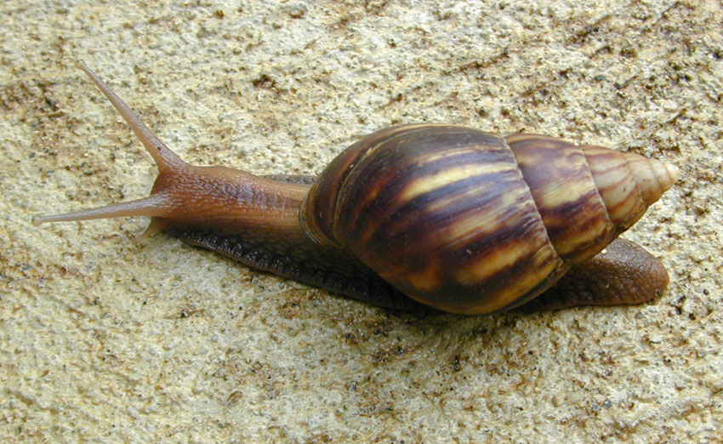

**What is it?**[Brief description]

**Suspected sightings should be reported immediately using the details   
provided at the bottom of this poster.**

**Where might I see it?**[are there any particular areas that this might be spotted—or pathways of   
introduction to highlight?]

Usually 5—10 cm (2-4”) long but can be up to 20 cm (8”)

Shell usually light brown   
with brown and cream bands

Tip of shell lighter

Image: Eric Guinther under Creative Commons Attribution Share Alike 3.0 unported license

**Have you seen this pest?**

**COMMON NAME**

*Scientific name*

**1664 491 2075**

Please report any sightings of this species by calling:

[insert website address?]