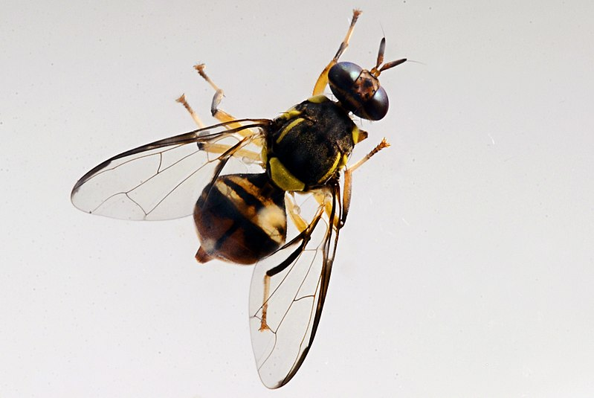

Adults may grow to more than 9 metres long

**What is it?**A fruit fly from southern Thailand, Peninsular Malaysia, Singapore, Borneo,   
Indonesia and Andaman Islands (India). Carambola fruit fly is a serious plant pest that feeds on over 100 plant species. **Suspected sightings should be reported   
immediately using the details provided at the bottom of this poster.**

**Where might I see it?**Fruit flies can be found as eggs or larvae in fruits or as adults caught in traps.   
Affected fruit may have puncture marks or globules of sugar on the skin.

**Have you seen this pest?**

**CARAMBOLA FRUIT FLY**

*Bactrocera carambolae*

**1664 491 2075**

Please report any sightings of this species by calling:

[insert website address?]

Image: Eric Guinther under Creative Commons Attribution Share Alike 3.0 unported license

Body 8 mm (0.3”) long

Image: Viwat Wornoayporn / IAEA Imagebank under Creative Commons Attribution Share Alike 2.0 unported license

Body with dark and yellow markings

Wings clear with dark band