Contingency plan for an incursion of
Tephritid fruit flies in the UK Overseas Territories

Contents
Introduction 3
Species covered 3
Summary of the stages in a response 5
Section I Anticipation and Preparation 6
A. Risk assessment 6
B. Training 6
C. Equipment 6
D. Detection 7
Section II Organisational framework 8
A. Roles and responsibilities 8
B. General considerations 9
C. Stakeholders 9
D. Communications 9
Section III Operational Plan 11
A. Immediate action on suspicion 11
B. Action on confirmation 11
C. Lessons learned 12
Annex 1. Species information 14
Annex 2. Roles of the Response Group and Operational Group 31
Annex 3. Best practice – monitoring and detection methods for Tephritid fruit flies 32
A. Guidelines for trap density and monitoring area 32
B. Monitoring using pheromone-baited delta traps. 35
C. Monitoring using baited bucket traps. 35
D. Sampling infested fruit 36
Annex 4. Best practice – control methods for Tephritid fruit flies 37
Annex 5. General biosecurity measures 40
Annex 6. Equipment suppliers 41

Introduction
This contingency plan covers an outbreak of a new invasive species of Tephritid fruit fly to a UK Overseas Territory (OT). It is concerned with the first detection of a new species and not with the containment, management or eradication of a more widely established population. Tephritid fruit flies are true flies (Insecta: Diptera) are of particular concern to the agricultural sector due to their destructive, economic impact on the production of orchard crops, tomatoes, peppers and squashes.
A new species of Tephritid fruit fly will be:
- Not native to the territory;
- Likely to survive in the territory;
- Able to spread by human mediated or natural means;
- Likely to become a pest and nuisance to social, environmental and economic values.

Species covered
This plan is targeted at the 8 species of Tephritid fruit fly of concern to 8 territories identified from the horizon scanning exercise carried out in 2018 / 2019 as shown in the table below. It can be adapted and applied to any other Tephritid fruit fly species.
Scientific name | Common name | St Helena | Ascension | Anguilla | Bermuda | Cayman Is | Montserrat | TCI | Pitcairn
Ceratitis capitata | Mediterranean fruit fly |  | x | x | x | x | x | x
Ceratitis cosyra | Mango fruit fly | x
Bactrocera carambolae | Carambola fruit fly |  |  |  | x | x | x | x
Bactrocera dorsalis | Oriental fruit fly | x |  |  |  |  |  |  | x
Bactrocera cucurbitae | Melon fly | x
Dacus bivittatus | Bigger pumpkin fly | x | x
Dacus ciliatus | Lesser pumpkin fly |  | x
Anastrepha obliqua | West Indian fruit fly |  |  |  |  | x
TCI = Turks & Caicos Islands.

Aim: To prevent a new Tephritid fruit fly species from establishing in the territory.

Objectives:
- Detect the arrival of a new Tephritid fruit fly species as soon as possible
- Contain and eradicate a newly detected population of Tephritid fruit flies
- Prevent further spread, by human mediated or other means
- Surveillance of ports of entry (high risk sites) to identify other possible incursions
- Raise public awareness to encourage reporting of other infestations
- Prevent new introductions arriving

If detected early, while still with a limited range and low numbers, it is possible to eradicate fruit flies using insecticides and elimination of host plants. The species could spread quickly so early action following detection would be important. Pathways of re-invasion need to be regulated to ensure the eradication was sustainable. It may not be possible to completely prevent re-invasion in the short term and contingency planning should be prepared to deliver responses to multiple separate invasions. Meanwhile, awareness raising on the need to report sightings can increase the chances of new arrivals being picked up.

The document has three main sections, together with a number of annexes giving additional information and best practice:
Section I covers preparation for readiness in anticipation of an incursion
Section II covers the organisational framework required to respond
Section III is the operational plan to be delivered in the event of an incursion

Summary of the stages in a response
Agencies / departments highlighted in yellow need to be identified.

Biosecurity strengthened to prevent reintroduction
Return to pre-invasion footing
Management responsibility moves to Agency TBA
Escalate
Stand down
Eradication unsuccessful
Eradication successful
Lead to establish Operational Group which delivers operational response with oversight of Response Group

Action to eradicate
Confirmed population
Lead to establish Response Group, who provide recommendations for action
Agency TBA to investigate
Response Group provides recommendations on when to stand down and / or escalate

Establish extent of population
Monitoring to confirm eradication
Suspected sighting
STAGE
RESPONSIBILITIES

Section I Anticipation and Preparation

This section covers actions which need to be in place for new potentially invasive species which have a high likelihood of arrival, and subsequent impact.

Risk assessment
Ideally risk assessments (rapid or detailed) and risk management appraisals should be completed before species invade. However, where this is not the case it should not prevent a response. Instead a rapid assessment should be completed as soon as possible following invasion.
A risk assessment for the accidental introduction of the West Indian fruit fly Anastrepha obliqua to the Turks & Caicos Islands was completed in 2020, see http://www.nonnativespecies.org//downloadDocument.cfm?id=2314. Simplified templates for pest risk assessments in the Overseas Territories, together with guidance on their completion, are available at http://www.nonnativespecies.org/index.cfm?pageid=658.
A summary of information on the main Tephritid fruit fly species of concern is given in Annex 1.

Training
Key operational staff need to be able to confidently identify and treat Tephritid fruit fly in the event of an incursion. The table below captures what skills are required, who already has these skills and where further training is needed. Training for key staff should be updated regularly, especially for new staff.
Skills required | Who has these skills | Who needs training
Identification of species
Rearing larvae to the adult stage
Larval monitoring
Adult monitoring
Pesticide application - insecticides

Equipment
Essential equipment required to implement the operation should be held in a centralised location. Items should be regularly replaced / tested / updated as appropriate by the person or agency responsible in each case.
What | How many/much | Where stored/ responsible
Coveralls, Type 3
Coveralls, Type 5/6, size L, XL
Face shield (to EN 166)
Nitrile gloves (0.5mm thick, 300mm long)
Respirator (EN 149 to EN 141)
Knapsack sprayer, 20l
Mistblower
Measuring jug
Pesticide transport box
Insecticide, eg cypermethrin

Detection
It is important to be aware of the different ways in which an incursion of a new species of fruit fly might get detected, so that the report of a sighting reaches the lead person at the designated agency (usually the Agriculture Department) as quickly as possible. This section covers who might spot it, and who they could tell. This information can be used to design Alert posters and awareness materials for the different groups. Best practice guidelines for monitoring Tephritid fruit flies is given in Annex 3.
Where | What is in place | Adequate? / What else is needed?
Points of entry - sea | ??? | ???
Points of entry - air | ??? | ???
Urban areas | ??? | ???
Rural areas | ??? | ???
Fruit growing areas | ??? | ???

Section II Organisational framework

This section provides the framework for action. The contingency plan requires the formation of a Response Group which oversees the plan, and an Operational Group which delivers the actions. There may be overlap between the members and functions of the two, and it is important that the lead person / agency of the Operational Group attends all Response Group meetings.
If the delivery lead is different from the policy lead there should also be a quality assurance plan to ensure that treatment is carried out to the appropriate standard. Details of the roles of the Response and Operational Groups are given in Annex 2.

Roles and responsibilities
Who / what agency is the policy lead? |  | TBC. This will depend on the territory
Who / what agency is the delivery lead? |  | TBC. This will depend on the territory
Roles and responsibilities – Response Group (oversight) | (List the agencies/bodies/people who will be involved in overseeing the eradication. Add lines as necessary)
 | Agency/body/person |  | Role
 | Agriculture Dept.? / Name of person
 | ???
 | ???
Roles and responsibilities – Operational Group (delivery) | (List the agencies/bodies/people who will be directly involved in the eradication actions. Add lines as necessary)
 | Agency/body/person |  | Role
 | Agriculture Dept.? / Name of person
 | ???
 | ???

General considerations
Legal provisions | (Identify the legislation which covers the eradication of plant pests, noting any critical gaps. Access to private property will be required).  - TBC. This will depend on the territory
Financial provisions | (Give an estimate of the cost of action, and who is responsible)  TBC. This will depend on the territory
Has a risk assessment been done? | (Summarise the results of the risk assessment, if available)  Not yet done? This will depend on the territory

Stakeholders
Key stakeholders affected by this species | (List the key stakeholders and note briefly their interest in this species – impacts or benefits. Add lines as necessary)
 | Stakeholder | Interests
 | Agriculture Department | Financial burden: losses to production, unsaleable produce due to presence of maggots, plus control costs and exposure to insecticides
 | Farmers | Financial burden: losses to production, unsaleable produce due to presence of maggots, plus control costs and exposure to insecticides
 | Gardeners | Financial burden: losses to production, inedible produce due to presence of maggots, plus control costs and exposure to insecticides
 | Public health | Increased exposure to pesticides by the farming sector
 | General public | Local produce inedible due to presence of maggots, and higher costs of buying a greater proportion of imported fresh produce
 | Hoteliers | Higher costs of buying imported fresh produce

Communications
Messages | (Define the main messages to be used in the different scenarios)
- on suspected sighting | “Have you seen this pest? The [name of fruit fly] is a new arrival in [name of place]. It is a serious pest of [affected crops] and threatens our livelihoods. Please report any sightings to xxx”  Plus images for identification.  In English and any other local languages
- on confirmed sighting | “Help us to eradicate this new pest. The [name of fruit fly] is a new arrival in [name of place]. It is a serious pest of [affected crops] and threatens our livelihoods.  - Do not move any [name of affected crops] out of [affected area]  - Do not move any soil out of [affected area]  - Avoid carrying adults by a quick spray of your vehicles with [name of locally available aerosol spray] before leaving [affected area]  - [anything else?]”  Plus images as guidance.  In English and any other local languages
- during eradication | As above.  Plus press releases justifying action to promote compliance and cooperation
- following removal | “Have you seen this pest? The [name of fruit fly] is a serious pest of [affected crops] and threatens our livelihoods. Please report any sightings to xxx”  Plus images for identification.  In English and any other local languages
- in the case of standing down | Messages to reduce impact: TBA depending on the species. This may include all or some of the following:  - Pruning fruit trees  - Planting alternative crops or varieties  - Collecting fallen fruit  - Pesticide treatment of trees and / or areas below trees  - Destruction of fruit trees
Responsibility for communications | (Identify who will be responsible for the various communications, and how they will do it. Add lines as necessary)
 | Agency | Medium
- Press lines for internal communications | ??? | Briefing memos
 | ??? | Guidance documents
 | ???
- With external stakeholders | ??? | Press releases, articles
 | ??? | Radio
 | ??? | Posters
 | ??? | Leaflets
 | ???

Section III Operational Plan

This section covers action to be taken in the event of an incursion.

Immediate action on suspicion
Actions to be taken by the lead agency, plus any appropriate members of the Operational Group team, once a new species of Tephritid fruit fly has been reported (see Section ID Detection) but identification and presence has not been confirmed. Note that this may involve rearing larvae to the adult stage as it is not usually possible to identify fruit flies from the larval stages.
Confirm identification | (Who confirms the identification as a new Tephritid fruit fly species?)  TBC. This will depend on the territory
Check extent of infestation / occurrence | Survey of area up to 500m from the point of first interception or detection (defined as zone 2); see best practice for monitoring Tephritid fruit fly in Annex 3.
Assess area of potential spread | Area of potential infestation is identified (neighbouring areas with likely host plants, pathways of infection, etc) within zone 2 (see Annex 3) and up to 4km downwind (see Annex 1 for species specific information on host plants and pathways of spread; see B below for general pathways of spread).
Notification | Response Group notified, to decide on further action if required.

Action on confirmation
A rapid response takes place when a new Tephritid species incursion has been confirmed by a competent authority.
The Department of Agriculture as the typical lead agency is usually responsible for initiating action.
Assessment of the situation | Detailed assessment of the incursion site using best practice guidelines outlined in Annex 3.
Pathways of spread to control movement out of the confirmed outbreak area (add lines as necessary)
Pathway | Mitigation actions | Who is responsible
Movement of infested produce | Not permitted out of the infested area, zone 2
Movement of infested soil | Not permitted out of the infested area, zone 2
Adult flies in vehicles | Routine aerosol spraying of vehicles leaving the infested area, zone 2
Wind-blown adults | Monitoring up to 4km downwind
Other locally important pathways? | TBC. This will depend on the territory
Eradication | Control using methods outlined in Annex 4.
Escalation and standing down | If for any reason initial eradication efforts are not successful, the Response Group will advise senior officials / Ministers on the need for escalation of eradication efforts or to stand down and move to long term management, considering:  - The level of expected economic and/or environmental impact of the species;  - Available mitigation measures;  - The cost-benefit of continued action  In the case that eradication effort is stood down, management responsibility would usually revert to those affected by the species (e.g. farmers, gardeners, householders, hoteliers, etc.). The Agriculture Department would usually be responsible for providing management advice to affected parties.
Post-eradication monitoring at incursion location | A typical pattern of progress for a successful intervention is as follows:  - Rapid response at each interception location;  - Intensive monitoring programme at each interception location for at least 6 months, as outlined in Annex 3;  - Reduced monitoring programme for 1 year (one full season);  - Some additional monitoring around the incursion area for a further 1 year.  Eradication should not be considered achieved until 2 years from the last sighting in the territory.

Lessons learned
It’s very important to have a lessons learned exercise after every incursion (anything that triggers a response) and to revise the contingency plan accordingly. This may include considerations such as:
- Certain pathways of introduction are a higher risk than expected;
- Biosecurity measures on certain pathways aren’t working;
- There are gaps in detection and reporting;
- The best practice guidelines require revision, etc.

Lesson learned (add lines as necessary) | Action needed | Responsible

Annex 1. Species information
There are around 5,000 species of Tephritid fruit flies, of which approximately 100 are considered pests. Tephritids have a typical fly shape, small to medium-sized (2.5–10 mm), with patterned wings, hence they are also known as the picture wing flies. Adults can be distinguished by the wing vein morphology and patterning. However, larvae tend to all look the same and it is very difficult to distinguish species. Interceptions of larvae usually need to be bred to the adult stage for identification.

A number of identification keys can be found on-line and require basic entomological skill and a microscope:
- Carroll L. E. et al. (2006) Pest fruit flies of the world. https://www.delta-intkey.com/ffl/intro.htm. Keys and descriptions of both adults and larvae are given.
- Steck G.J. et al. Methods for identification of Anastrepha larvae (Diptera: Tephritidae), and key to 13 species (1990) Proceedings of the Entomological Society of Washington v92 p333 – 346. https://www.biodiversitylibrary.org/page/26237920#page/343/mode/1up
- White I.M. and Elson-Harris M.M. (1992) Fruit flies of economic significance: their identification and bionomics. CAB International Wallingford UK.
- Virgilio M, White I, de Meyer M (2014) A set of multi-entry identification keys to African frugivorous flies (Diptera, Tephritidae). ZooKeys 428: 97-108. https://doi.org/10.3897/zookeys.428.7366. https://zookeys.pensoft.net/article/4091/list/9/

There are eight species of concern belonging to four genera. Adults are illustrated in the table below, and further information for each species is given in the appropriate factsheet which follow. A glossary of entomological terms can be found at https://www.earthlife.net/insects/glossary.html

Species | Image | Source
Mediterranean fruit fly, Ceratitis capitata | 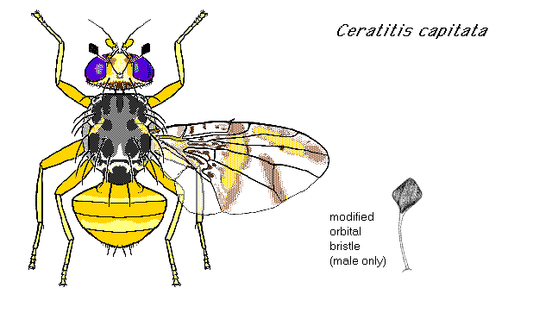 | Pest fruit flies of the world
Mango fruit fly Ceratitis cosyra | 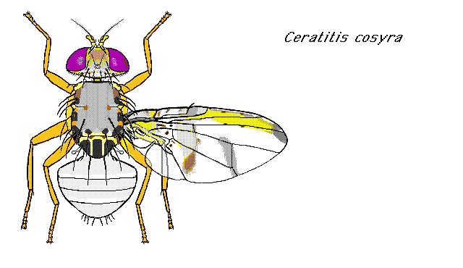 | Pest fruit flies of the world
Carambola fruit fly Bactrocera carambolae | 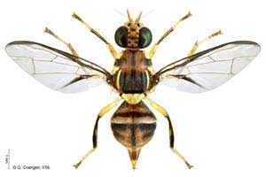 | https://baiotekunoruto.blogspot.com/2019/03/bioinsektisida-untuk-lalat-bactrocera.html
Oriental fruit fly Bactrocera dorsalis | 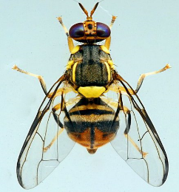 | Wikipedia
Bactrocera curcurbitae | 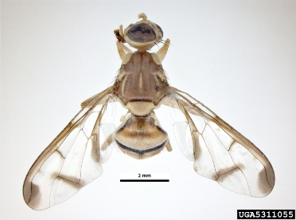 | https://enacademic.com/dic.nsf/enwiki/11513436
Greater pumpkin fly Dacus bivittatus | 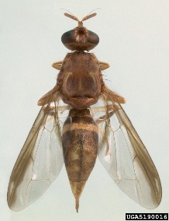 | Natasha Wright, Cook's Pest Control, Bugwood.org
Lesser pumpkin fly Dacus ciliatus | 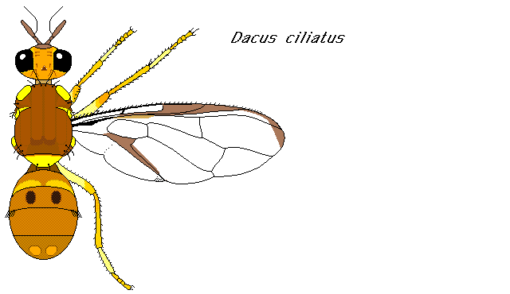 | Pest fruit flies of the world
West Indian fruit fly Anastrepha obliqua | 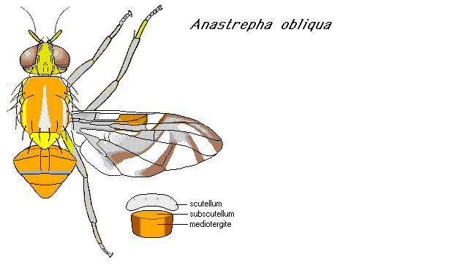 | Pest fruit flies of the world

Ceratitis capitata Mediterranean fruit fly (Medfly)
Description
Egg | Smooth and shiny white, slender and curved. 1 mm in length.
Juvenile | Larva are white with a typical fruit fly larval shape, i.e., cylindrical maggot-shape, elongate, anterior end narrowed and somewhat recurved ventrally, with anterior mouth hooks, and flattened rear end.  Larvae: Three larval instars, last instar 7 - 9 mm (0.28 - 0.35 in.) in length.  Pupae: Dark reddish-brown, 4 - 4.3 mm (0.16 - 0.17 in.) in length. Cylindrical.
Adult | 3.5 – 5 mm in length. Yellowish with brown accents, especially on abdomen and legs. The thorax is creamy white to yellow with a characteristic pattern of black blotches. Lower corners of the face have white setae (bristles). Eyes are reddish-purple. Ocellar bristles are present. The male has a pair of bristles with enlarged spatulate tips next to the inner margins of the eyes.  Wings, usually held in a drooping position on live flies, are broad and glassy with black, brown, and brownish yellow markings. There is a wide brownish yellow band across the middle of the wing. The apex of the wing's anal cell is elongate. There are dark streaks and spots in middle of wing cells in and anterior to anal cell.
Life cycle | Females deposit batches of 2-10 eggs in living, healthy plant tissue using their telescopic ovipositors, below the skin of the host fruit. They hatch within 2-4 days (up to 16-18 days in cool weather) and the larvae feed for another 6-11 days (at 13-28°C).  Pupation is in the soil under the host plant, the adults emerge in the early morning after 6-11 days (24-26°C; longer in cool conditions). Newly emerged adults are not sexually mature. Males often show sexual activity four days after emergence, and copulation has been observed five days after emergence. For females, ovarian development at 25°C takes 5 days and then the female is ready to breed. Both sexes are sexually active throughout the day.
Ecology and behaviour | The Medfly can breed in over 250 different hosts (see the CABI datasheet for a complete list of hosts).
Entry and colonisation
Pathway(s) of entry | - Infested fruit, either as cargo or in passengers luggage
Detection | See Annex 3.  Adults are collected primarily by use of sticky-board traps and baited traps. Males are attracted to trimedlure, terpinyl acetate and ceralure, and females to protein baits.
Similar species | See table above.
Where likely to colonise | Orchard fruit, coffee plantations, farms and gardens.  It’s very wide host range make it also likely to colonise the wider environment where larvae can be found in many native and ornamental garden plants which bear a fruit, including Opuntia cactus.
Longevity | Up to 6 months.
Dispersal methods | - Movement of infested fruit  - Movement of infested soil  - Movement of live plants, potted in infested soil  - Adults as hitchhikers in vehicles  - Adults as hitchhikers on clothes  - Wind-blown adults
Distribution | Native to most sub-Saharan countries, it now has a worldwide distribution in the tropics, subtropics and warm temperate zone.
Further information | - https://www.cabi.org/isc/datasheet/12367  - https://idtools.org/id/citrus/pests/factsheet.php?name=Mediterranean%20fruit%20fly  - http://entnemdept.ufl.edu/creatures/fruit/mediterranean_fruit_fly.htm

Ceratitis cosyra mango fruit fly
Description
Egg | Probably the same as described for C. capitata.
Juvenile | Larva are white with a typical fruit fly larval shape, i.e., cylindrical maggot-shape, elongate, anterior end narrowed and somewhat recurved ventrally, with anterior mouth hooks, and flattened rear end.
Adult | Body and wing color yellowish; sides and posterior of thorax prominently ringed with black spots, dorsum yellowish except for two tiny black spots centrally and two larger black spots near scutellum; scutellum with three wide, black stripes separated by narrow yellow stripes; wing length 4–6 mm, costal band and discal crossband joined.
Life cycle | Females deposit eggs in living, healthy plant tissue using their telescopic ovipositors, below the skin of the host fruit. There are three larval instars and they develop over a period of about 1 week. Final instar larvae of Ceratitis drop to the ground, find a crack to drop into, and then form a puparium (hardened larvae skin) within which pupation takes place; pupation lasts 10-12 days; adults may be expected to emerge after 1-2 weeks.  Females first oviposit at about age 5 days, and oviposition continues up to age 2 weeks, with up to 8 weeks in laboratory colonies. Fruits are heavily infested, with an average of 50 larvae per fruit.
Ecology and behaviour | The principle host of C. cosyra is maroola plum (Sclerocarya birrea) but it will also heavily attack mango (Mangifera indica); there are records from several other fruit crops including guava (Psidium guajava), citrus, early peaches (Prunus persica), avocado (Persea americana) and wild hosts belonging to a wide range of families (see the CABI datasheet for a complete list of hosts).
Entry and colonisation
Pathway(s) of entry | - Infested fruit, either as cargo or in passengers luggage
Detection | See Annex 3.  Some males are attracted to terpinyl acetate, both sexes to protein baits.
Similar species | C cosyra can be confused with C. discussa. Reliable separation is a specialist task. However, most specimens can be separated by the colour of the basal scutellar spots (yellowish in C. discussa and black in C. cosyra).  Adults are similar in size, coloration, and wing markings to C. capitata. However, the thorax of C. capitata has much more black, and the apex of its scutellum is solid black; the costal band and discal crossband of C. capitata wing are not joined.
Where likely to colonise | Orchard fruit, farms and gardens.
Longevity | 2 – 3 months
Dispersal methods | - Movement of infested fruit  - Movement of infested soil  - Movement of live plants, potted in infested soil  - Adults as hitchhikers in vehicles  - Adults as hitchhikers on clothes  - Wind-blown adults
Distribution | Present in all sub-Saharan African countries, introduced to Europe (Belgium).
Further information | - https://www.cabi.org/isc/datasheet/12370  - http://entnemdept.ufl.edu/creatures/fruit/tropical/mango_fruit_fly.htm

Bactrocera carambolae Carambola fruit fly

Description
Egg | Probably the same as described for B. dorsalis.
Juvenile | Larva are white with a typical fruit fly larval shape, i.e., cylindrical maggot-shape, elongate, anterior end narrowed and somewhat recurved ventrally, with anterior mouth hooks, and flattened rear end.  Third instar larva is medium-sized, length 7.5-9.5 mm; width 1.5-2.0 mm.  Puparium barrel-shaped with most larval features unrecognisable, the exception being the anterior and posterior spiracles which are little changed by pupariation. White to yellow-brown in colour. Usually about 60-80% length of larva.
Adult | 6-8 mm in length and have clear wings, generally black chests and paler abdomens with a distinctive black T-shaped marking on the back.
Life cycle | Females deposit eggs in living, healthy plant tissue using their telescopic ovipositors, below the skin of the host fruit.
Ecology and behaviour | Can breed in a wide range of different hosts (see the CABI datasheet for a complete list of hosts).
Entry and colonisation
Pathway(s) of entry | - Infested fruit, either as cargo or in passengers luggage
Detection | See Annex 3.  Monitored using methyl eugenol and cuelure, usually using a Steiner trap. The Steiner trap is an open horizontal plastic cylinder of approximately one litre volume. It has openings at each end of the trap for entry of flies and to allow free movement of the attractant vapour from the cotton wick. The Steiner trap is used in areas of high rainfall.
Similar species | Papaya fruit fly (Bactrocera papayae), Oriental fruit fly (Bactrocera dorsalis) and Carambola fruit fly (Bactrocera carambolae) are all part of the Oriental fruit fly complex. All three species look extremely similar and can only be distinguished by a fruit fly expert.  It differs from B. dorsalis in having a broader costal band overlapping R2+3 and expanding apically around R4+5, sometimes having a subapical spot on the fore femora, and having rectangular bands present on tergum IV.
Where likely to colonise | Orchard fruit, farms and gardens.
Longevity | At least 2 months
Dispersal methods | - Movement of infested fruit  - Movement of infested soil  - Movement of live plants, potted in infested soil  - Adults as hitchhikers in vehicles  - Adults as hitchhikers on clothes  - Wind-blown adults
Distribution | B. carambolae is found in Malaysia, the southern (peninsular) area of Thailand and throughout western Indonesia. Introduced to South America
Further information | - https://www.cabi.org/isc/datasheet/8700  - https://fruitflyidentification.org.au/surveillance-and-detection/methods-for-detection/

Bactrocera dorsalis Oriental fruit fly

Description
Egg | 0.8 mm long and 0.2 mm wide, with the micropyle protruding slightly at the anterior end, and white to yellow-white.
Juvenile | Larva are white with a typical fruit fly larval shape, i.e., cylindrical maggot-shape, elongate, anterior end narrowed and somewhat recurved ventrally, with anterior mouth hooks, and flattened rear end.  B dorsalis third-instar larva are medium-sized: 7.5-10.0 mm long and 1.5-2.0 mm wide.  Pupa barrel-shaped with most larval features unrecognisable, the exception being the anterior and posterior spiracles, which are little changed by pupariation. White to yellow-brown. Usually approximately 60-80% the length of the larva
Adult | 8mm in length. Colour is variable but with yellow and dark brown to black markings on the body segment where the wings attach.  Scutum generally black, varies in B. dorsalis from generally black to black with an extensive lanceolate red-brown pattern to almost entirely red-brown. Populations from the Indian subcontinent and Africa have extensive pale markings, whereas specimens from Asia east of Myanmar mostly have a dark scutum.
Life cycle | Females deposit eggs in living, healthy plant tissue using their telescopic ovipositors, below the skin of the host fruit.  The eggs of B. dorsalis are laid below the skin of the host fruit. These hatch within a day (although this can be delayed up to 20 days in cool conditions) and the larvae feed for another 6-35 days, depending on the season. Pupariation is in the soil under the host plant for 10-12 days at 25°C and 80% RH, but may be delayed for up to 90 days under cool conditions. The adults occur throughout the year and begin mating after approximately 8-12 days.
Ecology and behaviour | Can breed in over 350 different hosts, the major hosts being apple, guava, mango, peach and pear (see the CABI datasheet for a complete list of hosts).
Entry and colonisation
Pathway(s) of entry | - Infested fruit, either as cargo or in passengers luggage
Detection | See Annex 3.  Males are attracted to methyl eugenol.
Similar species | Papaya fruit fly (Bactrocera papayae), Oriental fruit fly (Bactrocera dorsalis) and Carambola fruit fly (Bactrocera carambolae) are all part of the Oriental fruit fly complex. All three species look extremely similar and can only be distinguished by a fruit fly expert.  Bactrocera carambolae differs from B. dorsalis in having a broader costal band overlapping R2+3 and expanding apically around R4+5, sometimes having a subapical spot on the fore femora, and having rectangular bands present on tergum IV.
Where likely to colonise | Orchard fruit, farms and gardens.
Longevity | 1-3 months, up to 12 months in cool conditions
Dispersal methods | - Movement of infested fruit  - Movement of infested soil  - Movement of live plants, potted in infested soil  - Adults as hitchhikers in vehicles  - Adults as hitchhikers on clothes  - Wind-blown adults
Distribution | Native to Asia, Oriental fruit fly is now found in at least 65 countries, including parts of America and Oceania, and most of continental Africa (sub-Saharan countries)
Further information | - https://www.cabi.org/isc/datasheet/17685  - https://idtools.org/id/citrus/pests/factsheet.php?name=Bactrocera  - https://fruitflyidentification.org.au/species/bactrocera-dorsalis/

Bactrocera cucurbitae Melon fly

Description
Egg | Probably the same as described for B. dorsalis: size, 0.8 mm long, 0.2 mm wide, with the micropyle protruding slightly at the anterior end. White to yellow-white in colour.
Juvenile | Larva are white with a typical fruit fly larval shape, i.e., cylindrical maggot-shape, elongate, anterior end narrowed and somewhat recurved ventrally, with anterior mouth hooks, and flattened rear end.  Third instar larva: Large, length 9.0-11.0 mm; width 1.0-2.0 mm.  Puparium barrel-shaped with most larval features unrecognisable, the exception being the anterior and posterior spiracles which are little changed by pupariation. White to yellow-brown in colour and distinctly ringed by narrow yellow bands around each segment. Usually about 60-80% length of larva.
Adult | Slightly larger than houseflies, 1/3 to 1/2 inch long with a wingspan of 1/2 to 3/5 inch. The head and eyes are dark brown. Their bodies are yellowish brown with a yellow spot above the base of the first pair of legs. A yellow stripe, with curved lines on either side, is present down the centre of the back. The tip of the body furthermost from the head is yellow. Wings are patterned with a thick brown band extending along the leading edge, ending in a larger brown spot at the tip. Another thin band extends from the wing base just inside the trailing edge of each wing. A brown spot occurs near the wing margin. Abdomens are reddish yellow with darker bands on the second and third abdominal segments. Legs are yellowish.
Life cycle | Females deposit eggs in living, healthy plant tissue using their telescopic ovipositors, below the skin of the host fruit. Eggs are inserted into fruit in bunches of 1 to 37. They hatch in 2 to 4 days.  The life cycle from egg to adult requires 14-27 days.  There are 3 larval stages for this insect. The larval period lasts from 6 to 11 days, with each stage lasting 2 or more days. Duration of larval development is strongly affected by host. Pupae occur in the soil beneath the host plant. During warm weather the pupal stage lasts 9 to 11 days.  Oviposition occurs about 10 days after emergence and continues at intervals. One female may deposit up to 1,000 eggs, although 300 eggs total are estimated in natural conditions. Females prefer to oviposit in new plant growth such as young seedlings, growing tips, and developing ovaries of all cucurbits except young cucumbers. Ripe fruits are preferred; green fruits are sometimes used. Because of their high egg laying capacity and mobility, each female is capable of destroying large numbers of fruit in her lifespan.
Ecology and behaviour | B cucurbitae is a very serious pest of cucurbit crops (pumpkins and squashes), with a number of other crops listed as secondary hosts (see the CABI datasheet for a complete list of hosts).  Eggs (up to 40) are laid below the skin of the host fruit; a female may lay more than 1000 eggs. These hatch within 1-2 days and the larvae feed for another 4-17 days (longest in thick-skinned fruits such as pumpkin). Pupariation is in the soil under the host plant for 7-13 days, but may be delayed for several weeks under cool conditions. Adults occur throughout the year and begin mating (at dusk) after about 10-12 days.  Melon flies are strong fliers. Adults spend considerable time on low, succulent, leafy vegetation surrounding cultivated areas.
Entry and colonisation
Pathway(s) of entry | - Infested cucurbits and fruit, either as cargo or in passengers luggage
Detection | See Annex 3.  Males are attracted to cuelure and methyl eugenol.
Similar species | B. cucurbitae is easily separated from most other Bactrocera and Dacus spp. by the combination of the coloured mark across the dm-cu crossvein (seen with the unaided eye as a reddish mark across the posterior half of the wing about one-third from wing apex), combined with the general reddish coloured body, and three bright yellow longitudinal vittae (stripes) on the scutum (dorsum of thorax).
Where likely to colonise | Farms and gardens where cucurbits are grown.
Longevity | 5-15 months depending on temperature
Dispersal methods | - Movement of infested fruit  - Movement of infested soil  - Movement of live plants, potted in infested soil  - Adults as hitchhikers in vehicles  - Adults as hitchhikers on clothes  - Wind-blown adults
Distribution | Native to India, B. cucurbitae, the melon fly, is now found in more than 40 countries, including many in Africa and Asia, the US, Slovenia and Australia.
Further information | - https://www.cabi.org/isc/datasheet/17683  - http://www.extento.hawaii.edu/kbase/crop/Type/bactro_c.htm  - https://enacademic.com/dic.nsf/enwiki/11513436

Dacus bivittatus Greater pumpkin fly

Description
Egg | Probably the same as described for B. dorsalis: size, 0.8 mm long, 0.2 mm wide, with the micropyle protruding slightly at the anterior end. White to yellow-white in colour.
Juvenile | Larva are white with a typical fruit fly larval shape, i.e., cylindrical maggot-shape, elongate, anterior end narrowed and somewhat recurved ventrally, with anterior mouth hooks, and flattened rear end.
Adult | 6.4-8.5 mm.
Life cycle | Females deposit eggs in living, healthy plant tissue using their telescopic ovipositors, below the skin of the host fruit.  Larvae develop inside the plant, and mature larvae pupate in the soil.
Ecology and behaviour | Can breed in cucurbits and citrus (see the CABI datasheet for a complete list of hosts).
Entry and colonisation
Pathway(s) of entry | - Infested fruit, either as cargo or in passengers luggage
Detection | See Annex 3.  Probably the same as for D. ciliatus.
Similar species
Where likely to colonise | Orchard fruit, farms and gardens.
Longevity | At least 2 months
Dispersal methods | - Movement of infested fruit  - Movement of infested soil  - Movement of live plants, potted in infested soil  - Adults as hitchhikers in vehicles  - Adults as hitchhikers on clothes  - Wind-blown adults
Distribution | Sub-Saharan Africa
Further information | - http://projects.bebif.be/fruitfly/descriptions/211.pdf

Dacus ciliatus Lesser pumpkin fly

Description
Egg | Probably the same as described for B. dorsalis: size, 0.8 mm long, 0.2 mm wide, with the micropyle protruding slightly at the anterior end. White to yellow-white in colour.
Juvenile | Larva are white with a typical fruit fly larval shape, i.e., cylindrical maggot-shape, elongate, anterior end narrowed and somewhat recurved ventrally, with anterior mouth hooks, and flattened rear end.
Adult
Life cycle | Females deposit eggs in living, healthy plant tissue using their telescopic ovipositors, below the skin of the host fruit.
Ecology and behaviour | D ciliatus is a major pest of a wide range of cucurbits in Africa, Asia and the Middle East.  D ciliatus adults reach their sexual maturity at 14-15 days although there are data from Egypt stating that the adults reach their reproductive maturity after 5-6 days during the summer and after 20-30 days during the winter. They usually stay coupled during the entire night and are separated by the morning light. Although not yet confirmed, it seems that females mate only once in their life span.  Females oviposit an average of 210 eggs in groups of 5-15. After the eggs hatch, the young larvae start to feed in the host, causing damage to the fruit. The final instar larvae drop to the ground, find a crack to drop into, and then form a puparium within which pupation takes place.  Under laboratory conditions on marrow fruits the following mean life spans were recorded: egg, 3.0 ± 0.8 days; larva, 7.3 ± 2.7 days; pupa, 9.3 ± 1.9 days; adult, 14-45 days.  In comparison to the related species B. cucurbitae, D. ciliatus is characterised by early reproduction, lower oviposition time, shorter life span, and lower fecundity
Entry and colonisation
Pathway(s) of entry | - Infested fruit, either as cargo or in passengers luggage
Detection | See Annex 3.  D. ciliatus is a particularly difficult species to detect or monitor as the males do not respond to the male lure chemical that is relied upon to detect most other pest species of Dacus or Bactrocera. The males are not attracted to cuelure or vert-lure. Detection is therefore only possible by examination of fruit for oviposition punctures and then rearing the larvae through to the adult stage. However, both sexes may be monitored using protein bait traps (either protein hydrolysate or protein autolysate).
Similar species | Compared to Bactrocera cucurbitae, it has longer egg incubation and immature stages, both disadvantages when competing for the same habitat. Preference for certain hosts allows D. ciliatus to enhance its biotic potential and maintain low population levels when competing with the melon fly, especially at low altitudes. D. ciliatus could colonize low temperature areas, as has been the case in Mediterranean areas. D. ciliatus seems less willing to exploit new hosts compared to B. cucurbitae.  It can be separated from other pest species within the Didacus subgenus by its lack of yellow vittae (stripes) on the scutum, and by the yellow spot in each haltere base being small and separated from the scutellum by at least its own diameter.
Where likely to colonise | Farms and gardens.
Longevity | Up to 4 months
Dispersal methods | - Movement of infested fruit  - Movement of infested soil  - Movement of live plants, potted in infested soil  - Adults as hitchhikers in vehicles  - Adults as hitchhikers on clothes  - Adult flight  - Wind-blown adults
Distribution | Africa and Asia
Further information | - https://www.cabi.org/isc/datasheet/17682

Anastrepha obliqua West Indian fruit fly

As in most other Anastrepha spp., the adults of A. obliqua are easily separated from those of other tephritid genera by a simple wing venation character; vein M, the vein that reaches the wing margin just behind the wing apex, curves forwards before joining the wing margin. Furthermore, most Anastrepha spp. have a very characteristic wing pattern; the apical half of the wing has two inverted 'V'-shaped markings, one fitting within the other; and a stripe along the forward edge of the wing, which runs from near the wing base to about half-way along the wing length.
Description
Egg | Eggs of A. obliqua bear a conspicuous lobe on the anterior (micropyle) end, which projects outside the fruit peel and is believed to aid in respiration. This lobe is lacking in related species, thus eggs inside the abdomens of gravid females can provide a useful diagnostic character for this species.
Juvenile | Larva are white with a typical fruit fly larval shape, i.e., cylindrical maggot-shape, elongate, anterior end narrowed and somewhat recurved ventrally, with anterior mouth hooks, and flattened rear end.  Medium-sized; 7.5-9.0 mm long; 1.4-1.8 mm wide.
Adult | The body is predominantly yellow to orange-brown, and the setae are red-brown to dark-brown. Wing: 5.7-7.5 mm long.
Life cycle | Females deposit eggs singly in living, healthy plant tissue using their telescopic ovipositors, below the skin of the host fruit. The larval stage lasts 10 to 13 days in summer, slightly longer in winter, and the pupal stage occupies about the same length of time. Possibly six or seven generations develop annually.
Ecology and behaviour | A obliqua is the most important fruit fly pest of mango (Mangifera indica) in the Neotropics and attacks a broad range of other fruits (see the CABI datasheet for a complete list of hosts). Citrus, mango and guava are key hosts implicated in its spread through trade.  The eggs are laid singly, below the skin of the host fruit. The larvae hatch within 3-12 days and feed for another 15-32 days. Pupariation is in the soil under the host plant and the adults emerge after 15-19 days (longer in cool conditions).  There is evidence that the adults of Anastrepha spp. can fly as far as 135 km.
Entry and colonisation
Pathway(s) of entry | - Infested fruit, either as cargo or in passengers luggage
Detection | See Annex 3.  No male lures have yet been identified for Anastrepha spp. However, they are captured by traps emitting ammonia. McPhail traps are usually used for the capture of Anastrepha spp. and possible baits are ammonium acetate, casein hydrolysate and torula yeast. The number of traps required per unit area is high; in a release and recapture test, Calkins et al. (1984) placed 18 traps per 0.4 ha and only recovered about 13% of the released flies.
Similar species | A. obliqua adults are difficult to separate from those of Anastrepha fraterculus, Anastrepha sororcula, Anastrepha zenildae, Anastrepha turpiniae, Anastrepha suspensa and several other species of the fraterculus group; if necessary, specimens should be referred to a specialist.
Where likely to colonise | Orchard fruit (particularly mangoes), farms and gardens.
Longevity | No information.
Dispersal methods | - Movement of infested fruit  - Movement of infested soil  - Movement of live plants, potted in infested soil  - Adults as hitchhikers in vehicles  - Adults as hitchhikers on clothes  - Active flight by adults (up to 135km)  - Wind-blown adults
Distribution | Europe (Netherlands and Slovenia), Caribbean, North America and South America
Further information | - https://www.cabi.org/isc/datasheet/5659  - http://entnemdept.ufl.edu/creatures/fruit/tropical/west_indian_fruit_fly.htm

Annex 2. Roles of the Response Group and Operational Group

Response Group
The Response Group is responsible for oversight of the work, and represents the policy lead.
The Response Group will determine when to move from the eradication phase to the monitoring phase and determine when monitoring can stop as a result of successful eradication.

Operational Group
The Operational group represents the delivery lead. On instruction from the Response Group, the Operational Group, will:
- Undertake additional monitoring / surveillance as necessary to establish the likely extent of the population.
- Provide advice on the best eradication strategy to use and any site specific issues to be overcome.
- Liaise with landowners and interested parties as necessary to obtain access and other permissions, if necessary utilising species control orders.
- Implement the eradication strategy.
- Monitor the site following eradication to ascertain success.
- Investigate the source of the outbreak.
These steps are not detailed or exhaustive, additional steps may be required as determined by the Response Group on advice from the Operational Group.

Quality assurance
The agency tasked with delivery should have a quality assurance plan to assess the effectiveness of treatments. For example, adult or larval Tephritid fruit fly numbers can be assessed post-treatment.
Private companies that engage with plant pest control may not do what they promise, so the Operational Group should be responsible for checking their work.

Annex 3. Best practice – monitoring and detection methods for Tephritid fruit flies

Adult Tephritid fruit flies are monitored using traps, baited with a lure or attractant. Various trap designs are available. Descriptions of trap common trap designs can be found at:
- https://fruitflyidentification.org.au/surveillance-and-detection/methods-for-detection/
- http://www-naweb.iaea.org/nafa/ipc/public/trapping-web.pdf
- https://www.springer.com/gp/book/9789401791922
Lures typically consist of sex pheromones or food baits. Different species are attracted to different lures, see the table below.

Species | Attractants for males | Attractants for females
Ceratitis capitata | Trimedlure  Terpinyl acetate  Ceralure | Protein baits
Ceratitis cosyra | Terpinyl acetate  Protein baits | Protein baits
Bactrocera carambolae | Methyl eugenol  Cuelure | Protein baits?
Bactrocera dorsalis | Methyl eugenol | Protein baits?
Bactrocera cucurbitae | Cuelure  Protein baits | Protein baits
Dacus bivittatus | Protein baits? | Protein baits?
Dacus ciliatus | Protein baits | Protein baits
Anastrepha obliqua | Ammonia | Ammonia

Guidelines for trap density and monitoring area
Deciding how many traps to place.
- These areas are recommended guidelines. Note that the size of each zone may vary depending on the species and exact nature of the location and any variation from the guidelines will be agreed by the Operational Group.
- On a map, mark the location where the novel species was found.
- Draw a circle with a radius of 100m. The area inside the circle is zone 1.
- Draw a second circle with a radius of 500m. The area inside the circle, and excluding the bit already covered by zone 1, is zone 2.
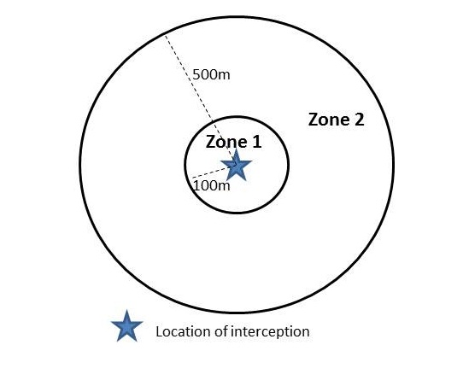
- This is illustrated in the diagram below.
- In zone 1 place traps at a density of up to 10 traps per hectare. For a circle of radius 100m the area is 3.14 hectares, which equals up to 30 traps placed in zone 1 (rounded down).
- In zone 2 place traps at a density of up to 2 traps per hectare. For a circle of radius 500m (minus the area already covered by zone 1) the area is 75.35 hectares, which up to 150 traps placed in zone 2 (rounded down).
- Note that there may be areas within zones 1 and 2 which are considered unsuitable for fruit flies or inaccessible and the figures should be adjusted accordingly.
- Outside zone 2, fill in the gaps in the existing monitoring trap network for the area, aiming to place around 1 trap per square kilometre.
- Repeat the above for every new interception of the novel species which takes place outside the initial zone 1.
- The outbreak source can be tracked by analysing the pattern of consecutive interceptions in terms of factors such as dispersal pathways, distribution of host plants, etc.
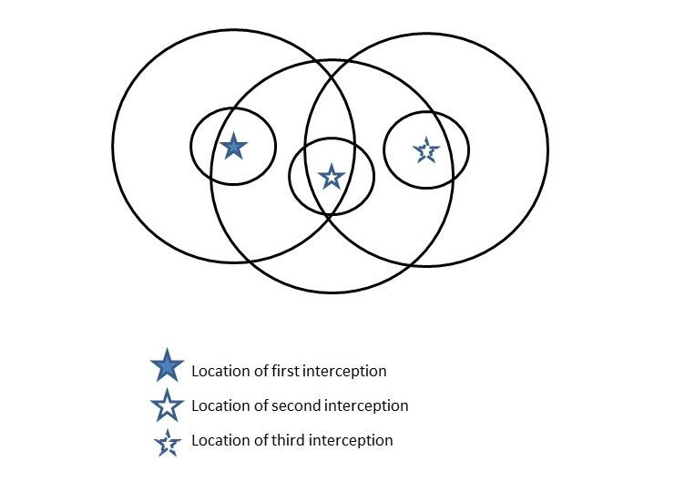
- The diagram below illustrates the track of 3 interceptions, showing the overlapping zoning which can occur. Exact trap numbers for each zone are decided by the Operational Group, based on local knowledge and the specific details of the incursion.
- An initial interception could be followed by a scatter of subsequent interceptions as new specimens are detected in traps placed in zones 1 and 2. This is illustrated in the diagram below. In cases such as this, the Operational Group will decide exactly how to proceed. Suggested actions are:
  - Expand zone 2 around the single point: it may be a one-off
  - Create a new zone 1 and 2 around the dense cluster of points
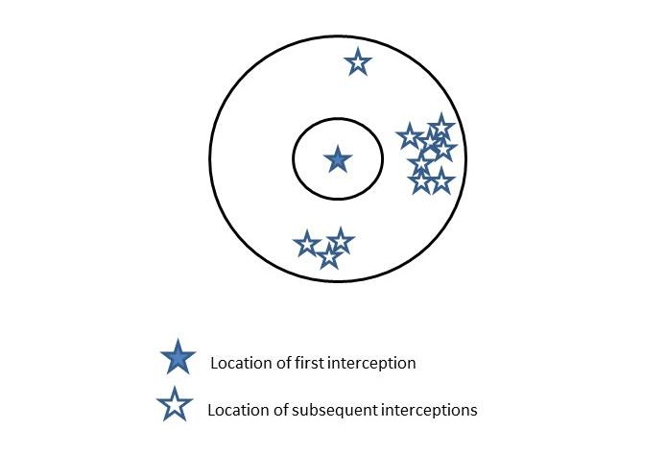
  - Use local knowledge to decide how to react to the cluster of 3 points

How often to check traps
- Initially, all traps in zones 1 and 2 should be checked once a week. Other additional traps outside zone 2 are ideally also checked once a week or at least once a fortnight.
- When no further interceptions have been detected for 4 weeks clear, trap checks can be made fortnightly.
- When no further interceptions have been detected for at least 3 further months clear, trap checks can be made monthly.
- When no further interceptions have been detected for at least 2 further months clear (a total of 6 months with no interceptions), trap density can be thinned throughout the monitoring area, and checks continued to be made monthly.
- The timing and extent of the reduction of effort will depend on species, season, and the exact nature of the incursion, and will be agreed by the Operational Group.
- Any new interceptions will take the procedure back to the beginning again.

Monitoring using pheromone-baited delta traps.
This procedure is to monitor Tephritid fly species for which there is a pheromone lure.
- Delta traps are placed in trees, ideally fruit trees, 1.5m to 2m high above the ground.
- Each trap is given a unique number and its location mapped, either by GPS or a sketch map.
  - For numbering, use a code of at least 5 digits to make it compatible with GPS. For example AZ1001 (= location A, Zone 1, trap number 001).
- Each Delta trap contains a sticky insert to catch insects, and a species specific pheromone lure.
- Pheromone lures are replaced as required.
- Guidelines for trap density and checking frequency are given in Annex 3A.
- Data is recorded in the field, and then entered in an Excel database, noting:
  - Date of check
  - Unique number of the trap
  - Zone
  - Catch, specifically Tephritid fruit flies

Monitoring using baited bucket traps.
This procedure is to monitor Tephritid fly species for which there is no pheromone lure.
- Bucket traps are placed in fruit trees, 1.5m to 2m high above the ground
- Each trap is given a unique number and its location mapped, either by GPS or a sketch map.
  - For numbering, use a code of at least 5 digits to make it compatible with GPS. For example AZ1001 (= location A, Zone 1, trap number 001).
- Each bucket trap contains 200 – 200ml water with a dash of detergent to contain and kills insects, and baited in the lid consisting of both fruit and hydrolysed protein
- Guidelines for trap density and checking frequency are given in Annex 3A.
- Data is recorded in the field, and then entered in an Excel database, noting:
  - Date of check
  - Unique number of the trap
  - Zone
  - Catch, specifically Tephritid fruit flies

Sampling infested fruit
This method is to check for the presence of maggots, which are collected and reared to the adult stage for identification.
- Collect infested fruit:
  - From the ground or the tree (as long as they are seen to contain maggots)
  - Aim for 1kg per fruit type per site
- Place in a breeding cage:
  - 2-3cm of sterilised sand at the base of the cage
  - Keep moist by spraying tap water as required
  - Hold at 18 to 20°C
- Fruit is held until all maggot stages are either dead or bred through; this may be more than 6 months, depending on the season.
- Adult flies are collected, identified, sexed, and either destroyed or preserved

Annex 4. Best practice – control methods for Tephritid fruit flies

Control strategy – immediate action and rapid response
- Confirmation of identification of species (adult phase) made by one or more of the following:
  - Samples sent to a local expert
  - On-line resources
  - Digital photos sent to a local expert, international expert or diagnostic laboratory such as Fera, UK
  - Samples sent to an international expert or diagnostic laboratory such as Fera, UK
- Plan of action. Details will depend on the exact nature of the interception, such as time of year, location, and species concerned, etc., and will include:
  - Determination of the size of the area to be surveyed and monitored, see Annex 3A;
  - Access to private properties and any likely issues;
  - Guidance on accessing steep or hazardous terrain:
    - Assessment of host plants present
    - Monitoring effort required at the borders
    - Treatment options
    - Access options, if required
  - Preparation of equipment and materials;
  - Organisation of labour and transport.
- Note that there are two possible reactions at this point: (i) map the extent of the infestation before moving on to treatment, OR (ii) initiate treatment more or less at the same time as mapping.
  - If there are relatively few flies in the delta traps, it is recommended that mapping is done first;
  - If there are large numbers of flies in the delta traps it is recommended that treatment is initiated as soon as possible, as any delay could compromise the chance of successful elimination.
- Extent of infestation determined in the defined area around the site of known infestation by:
  - Placing pheromone-baited delta traps (see Annex 3B) where pheromone lures are available; OR
  - Placing protein baited bucket traps (see Annex 3C) where pheromone lures aren’t available.
  - Trap density and checking rates to be agreed by the planning group, based on guidelines laid out in Annex 3A;
  - Sampling infested fruit and breeding through; see Annex 3D. Note that it may take some time for maggots to breed through.
- Elimination of the incursion. This may include, as appropriate:
  - Pesticide treatment of infected trees, other host plants, and below host trees using a registered product such as Malathion or Cypermethrin, following label instructions.
  - Splash-baiting of fruit trees and surrounding vegetation using a protein bait and registered product such as Malathion or Cypermethrin, following label instructions.
  - Destruction of infected trees, crops and other host plants.
  - Widespread severe pruning of fruit trees and other potential host trees.
- Area of potential infestation is identified (neighbouring areas with likely host plants, pathways of infection, etc) within zone 2 and up to 4km downwind.
- There are 3 possible scenarios resulting from the actions outlined above:
- Numbers decline to zero and no further interceptions are detected.
  - Monitoring continues and is wound down following the guidelines in Annex 3A.
- Numbers remain constant or increase.
  - Further actions required (see the section below)
- Other interceptions are detected in separate locations.
  - Further actions required (see the section below)

Control strategy – further actions
- Further actions may include all or any of those listed below. Additional resources (labour, materials, etc.) and powers may be required at this stage.
- If legally possible, declaration of quarantine in the infested area.
- All movements of fruit controlled on and off the area.
- Territory-wide eradication programme initiated which may include, as appropriate:
  - District-wide destruction of crops or trees.
  - District-wide pesticide treatment will be considered, if necessary.
  - Widespread severe pruning of fruit trees and other potential host trees.
  - Visits to promote management techniques which reduce infection and spread, and raise awareness of symptoms and preventing spread.
  - Where suspicion is raised of a possible outbreak, visits made to check crops, fruit trees and other likely host plants.
- GIS mapping of hosts, refuges, location of prey species, dispersion pathways, or other key information, as appropriate, to predict likely patterns of dispersion.

Contingency plan: in the event of further outbreaks in other districts
- The same procedure will be followed as laid out for the initial interception.
- Extent of infestation determined in zones 1 and 2 around the new location using the same method as used for the initial incursion, based on the guidelines in Annex 3A.
- Elimination of the new incursion. This may include, as appropriate:
  - Pesticide treatment of infected trees, other host plants, and below host trees using a registered product such as Malathion or Cypermethrin, following label instructions.
  - Splash-baiting of fruit trees and surrounding vegetation using a protein bait and registered product such as Malathion or Cypermethrin, following label instructions.
  - Destruction of infected trees, crops and other host plants.
  - Widespread severe pruning of fruit trees and other potential host trees.
- Suspected outbreaks which have not been confirmed may be subject to precautionary treatment pending confirmation.
- If numbers decline to zero and no further interceptions are detected, monitoring continues and is wound down following the guidelines in Annex 3A.
- If numbers remain constant or increase reaction will be proportionate to the level of risk identified, and may include:
  - District-wide destruction of crops or trees.
  - District-wide pesticide treatment will be considered, if necessary.
- Declaration of quarantine in the infected area.
- Analysis of the pathway of dispersal to try and predict and prevent new outbreak areas.
- GIS mapping of hosts, refuges, location of prey species, dispersion pathways, or other key information, as appropriate, to predict likely patterns of dispersion

Control strategy – when to stop
- A typical pattern of progress for a successful intervention is as follows:
  - Rapid response at each interception location;
  - Intensive monitoring programme at each interception location for at least 6 months, as outlined in Annex 3A;
  - Reduced monitoring programme for 1 year (one full season);
  - Some additional monitoring around the incursion area for a further 1 year.
- Eradication should not be considered achieved until 2 years from the last sighting on the island.
- In the event of an unsuccessful intervention, the Response Group should consider when it is appropriate to step down the emergency response, considering:
  - The level of expected economic and/or environmental impact of the species;
  - Available mitigation measures;
  - The cost-benefit of continued action.

Biosecurity
- An important aspect is to analyse the introduction pathway, if possible, to minimise the risk of further incursions.
- Biosecurity inspectors should analyse fresh produce imports for at least the two voyages previous to detection of the novel species to assess the likelihood of this pathway, noting any interceptions, and considering the main hosts of the species, season and seasonality.
- Biosecurity actions for a specified number of voyages to be agreed by the Response Group may include, as appropriate:
  - Sampling rates increased for identified high risk produce groups;
  - Temporary ban on identified high risk produce groups;
  - Temporary ban on high risk produce groups with specific Production Unit Codes.
- General biosecurity measures to be followed are given in Annex 5.

Annex 5. General biosecurity measures

This procedure is for all users of infested zones / declared quarantine areas.
- No fruit/produce to be moved outside the area.
- No soil to be moved outside the area.
- Vehicles can carry adult fruit flies. Where possible they should be parked outside the area, and movement of vehicles in and out of the area minimised. Vehicles which are required to move in and out of the area should be lightly sprayed inside and out on a daily basis with a residual contact insecticide such as a commercially available “Doom” or “Mortein” spray.
- Restrict the number of essential visitors moving in and out of the area, to avoid inadvertent carrying of adult flies on clothing, packs, vehicles etc.
- Discourage non-essential visitors, especially if they also have crops or plants which might be infected.
- A separate set of disposable protective clothing or waterproof protective clothing and waterproof boots to be worn within the declared quarantine area, and not used on any other plot outside it.
- All equipment used must be clean on arrival and on departure. Great care must be taken when cleaning electrical apparatus or tools. Where possible equipment should be protected from contamination e.g. using plastic bags. Health and Safety rules must be observed. Where equipment can be cleansed and disinfected this must be done before entry to the area and again on departure.
- Sufficient water, disinfectant and disinfecting equipment should be taken on the visit, even if facilities for disinfecting clothes, footwear, equipment or vehicles are thought to be available in the area.

Annex 6. Equipment suppliers

Below is given a list of some suppliers of specialist equipment. The list is not exhaustive and should not be taken as an endorsement of the company or brand.

Company | Equipment supplied | Link
ISCA (USA) | Traps  Lures and baits | https://www.iscatechnologies.com/
BioQuip (USA) | Traps  Lures and baits  Entomological equipment, general | https://www.bioquip.com/
Biobest (Belgium) | Traps  Lures and baits | https://www.biobestgroup.com/
Natural History Book Society (UK) | Traps  Lures and baits  Entomological equipment, general | https://www.nhbs.com/
Watkins and Doncaster (UK) | Entomological equipment, general | https://www.watdon.co.uk/
Wildcare (UK) | Entomological equipment, general | https://www.wildcare.co.uk/

http://www.nonnativespecies.org/index.cfm?pageid=634

